**Name: Arya Kashikar**

**PRN: 22070521036**

**Course- Certified System Administrator**

**Lab 3.3.1 - Add Category and Reference Values**

* **Section 1:**

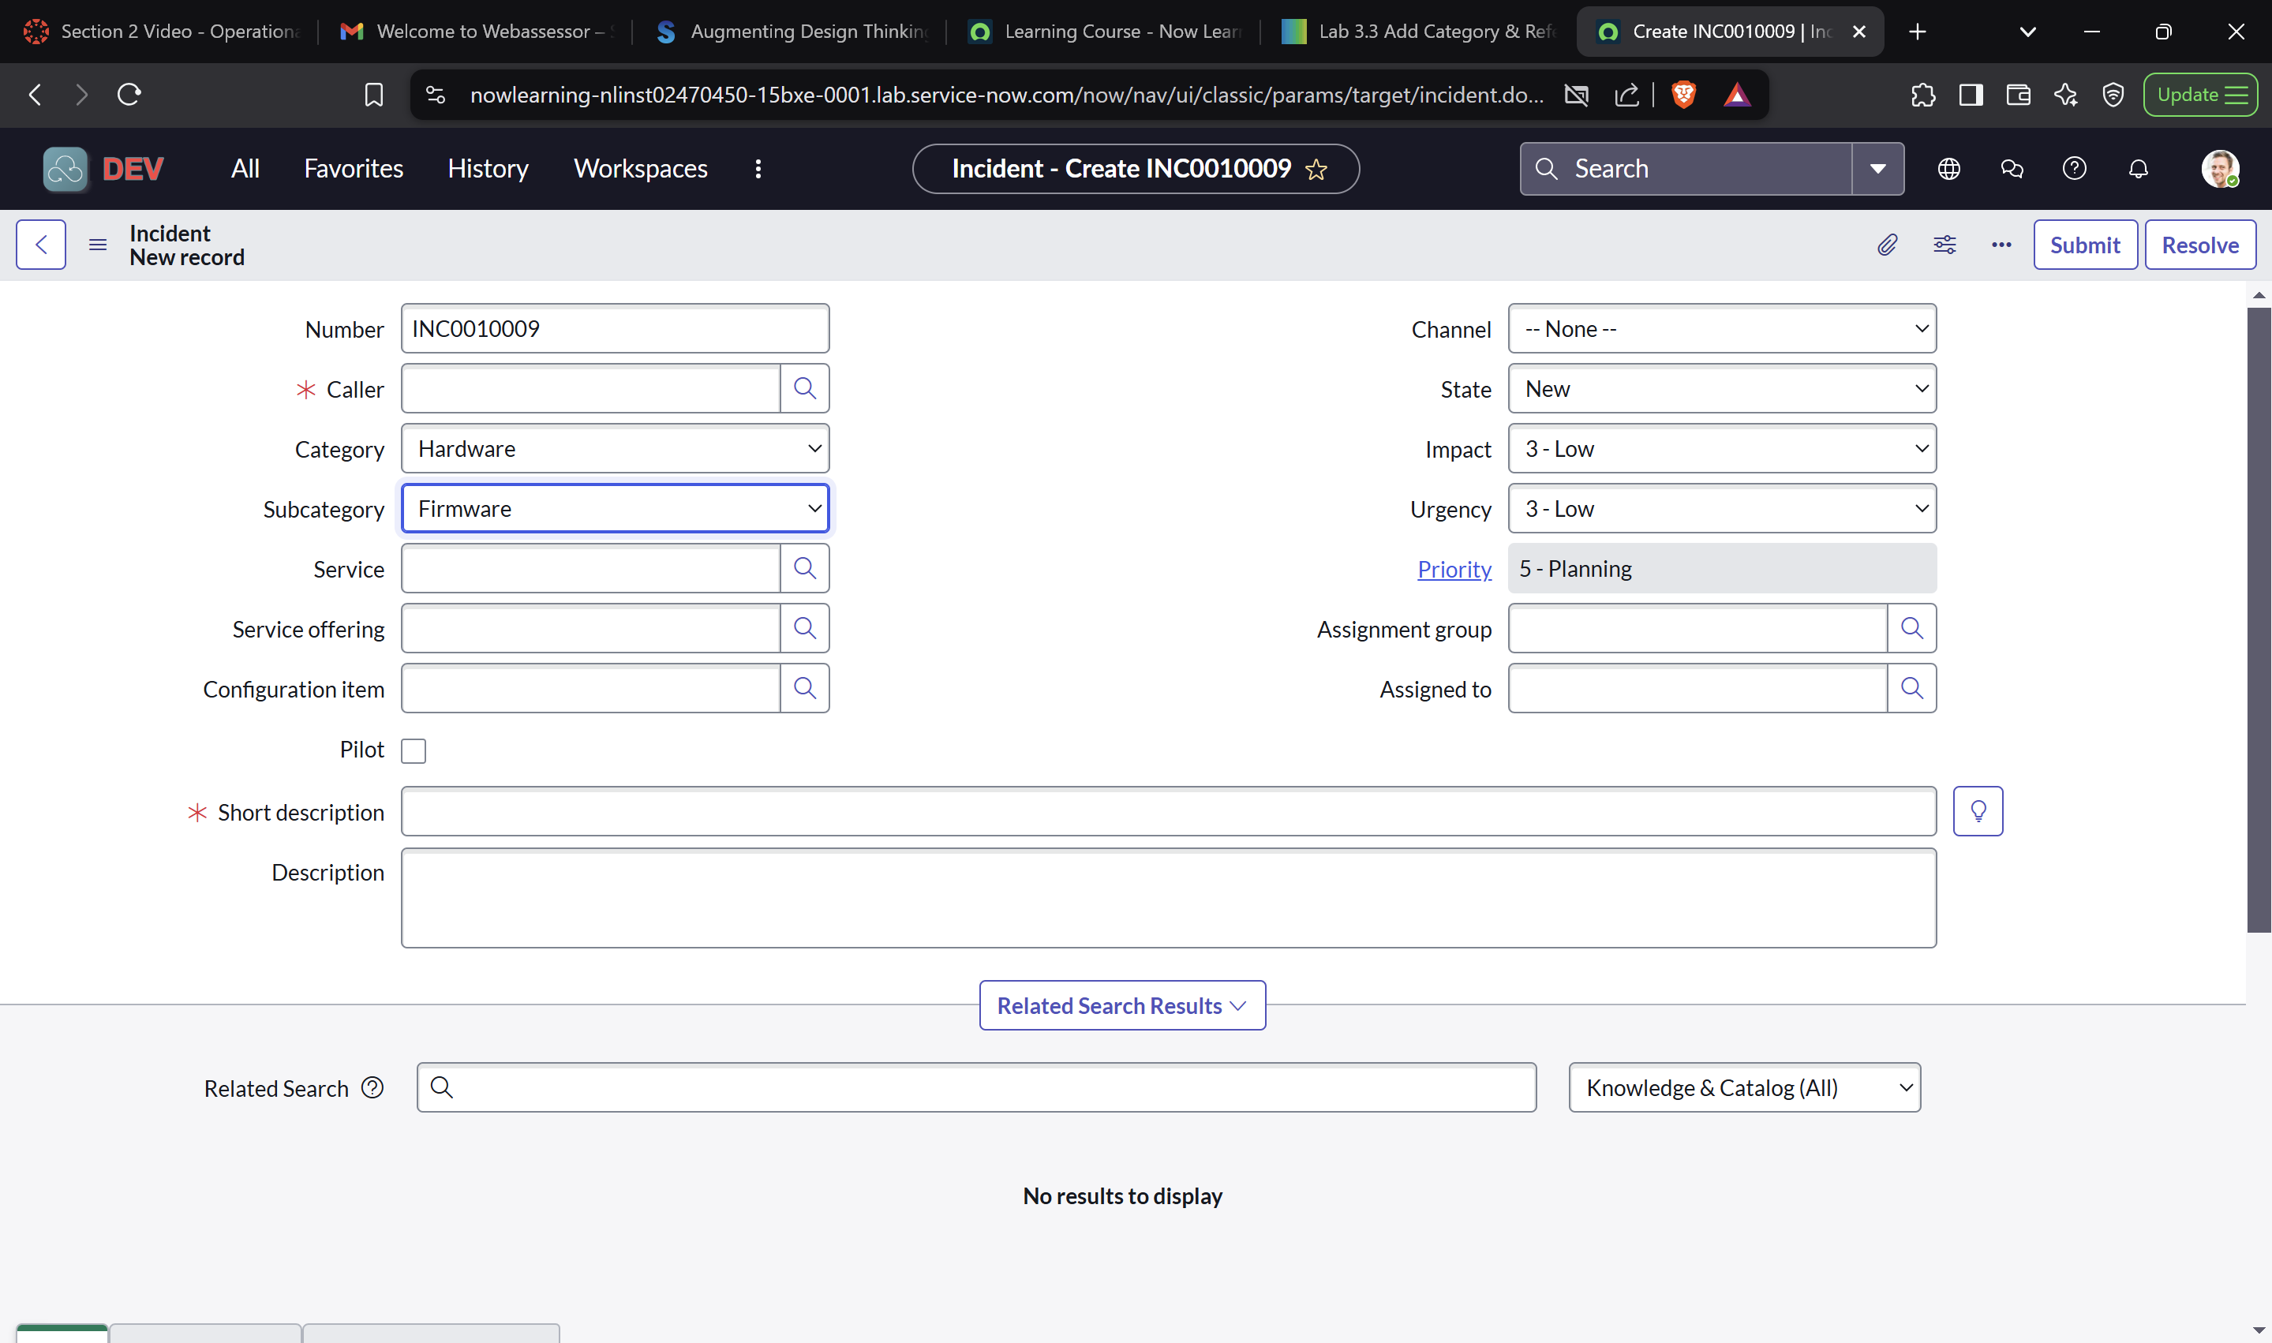

* **Section 2:**

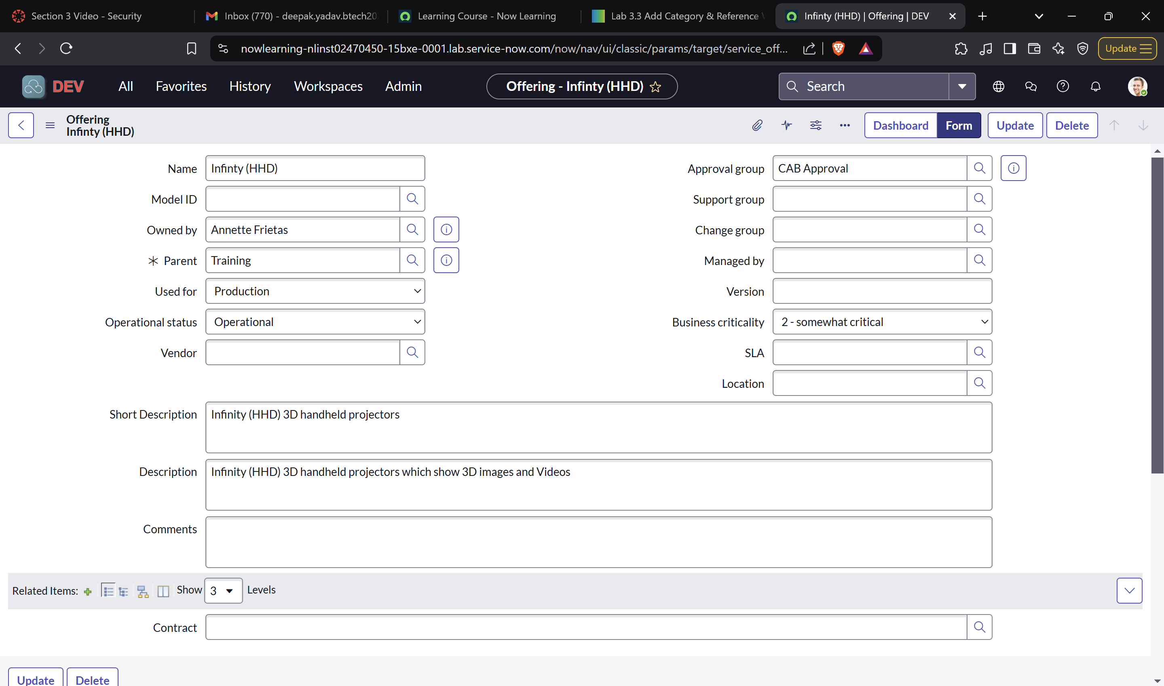

* **Section 3 :**

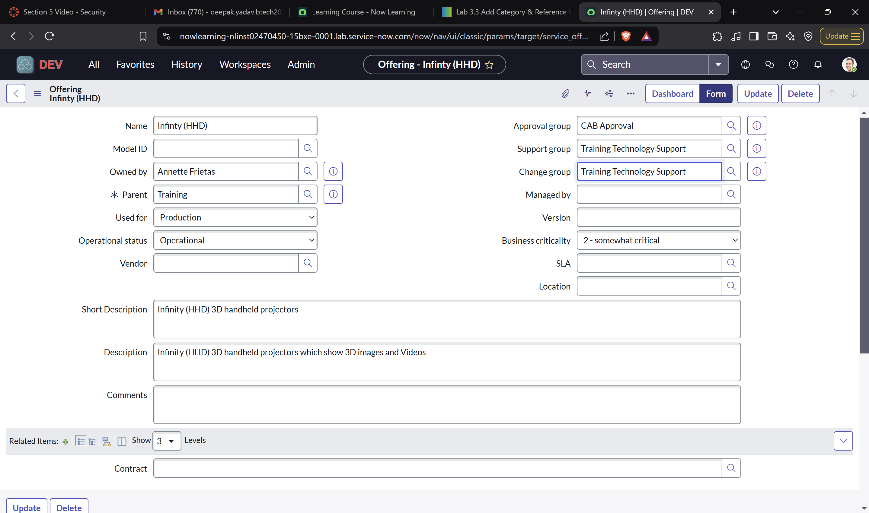

* **Section 4 :**

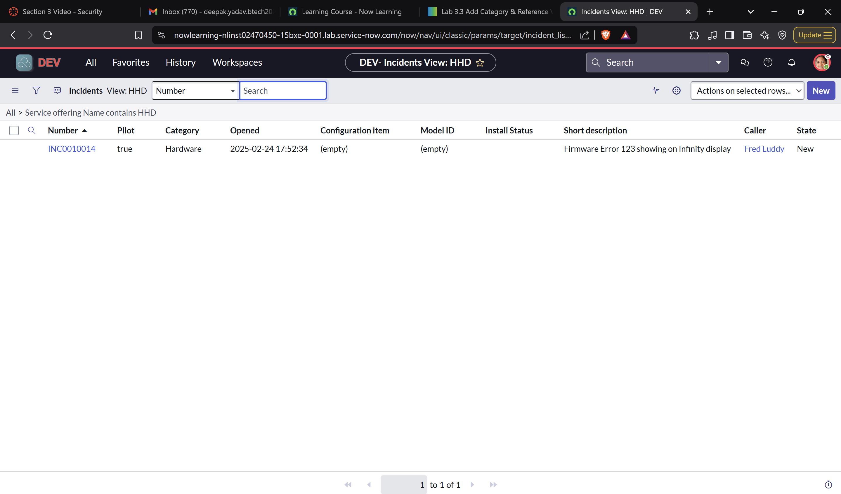

**Lab 4.1 Create Table for HHD Configuration Records**

**Section 1: Create a New Table, Column and List Layout**

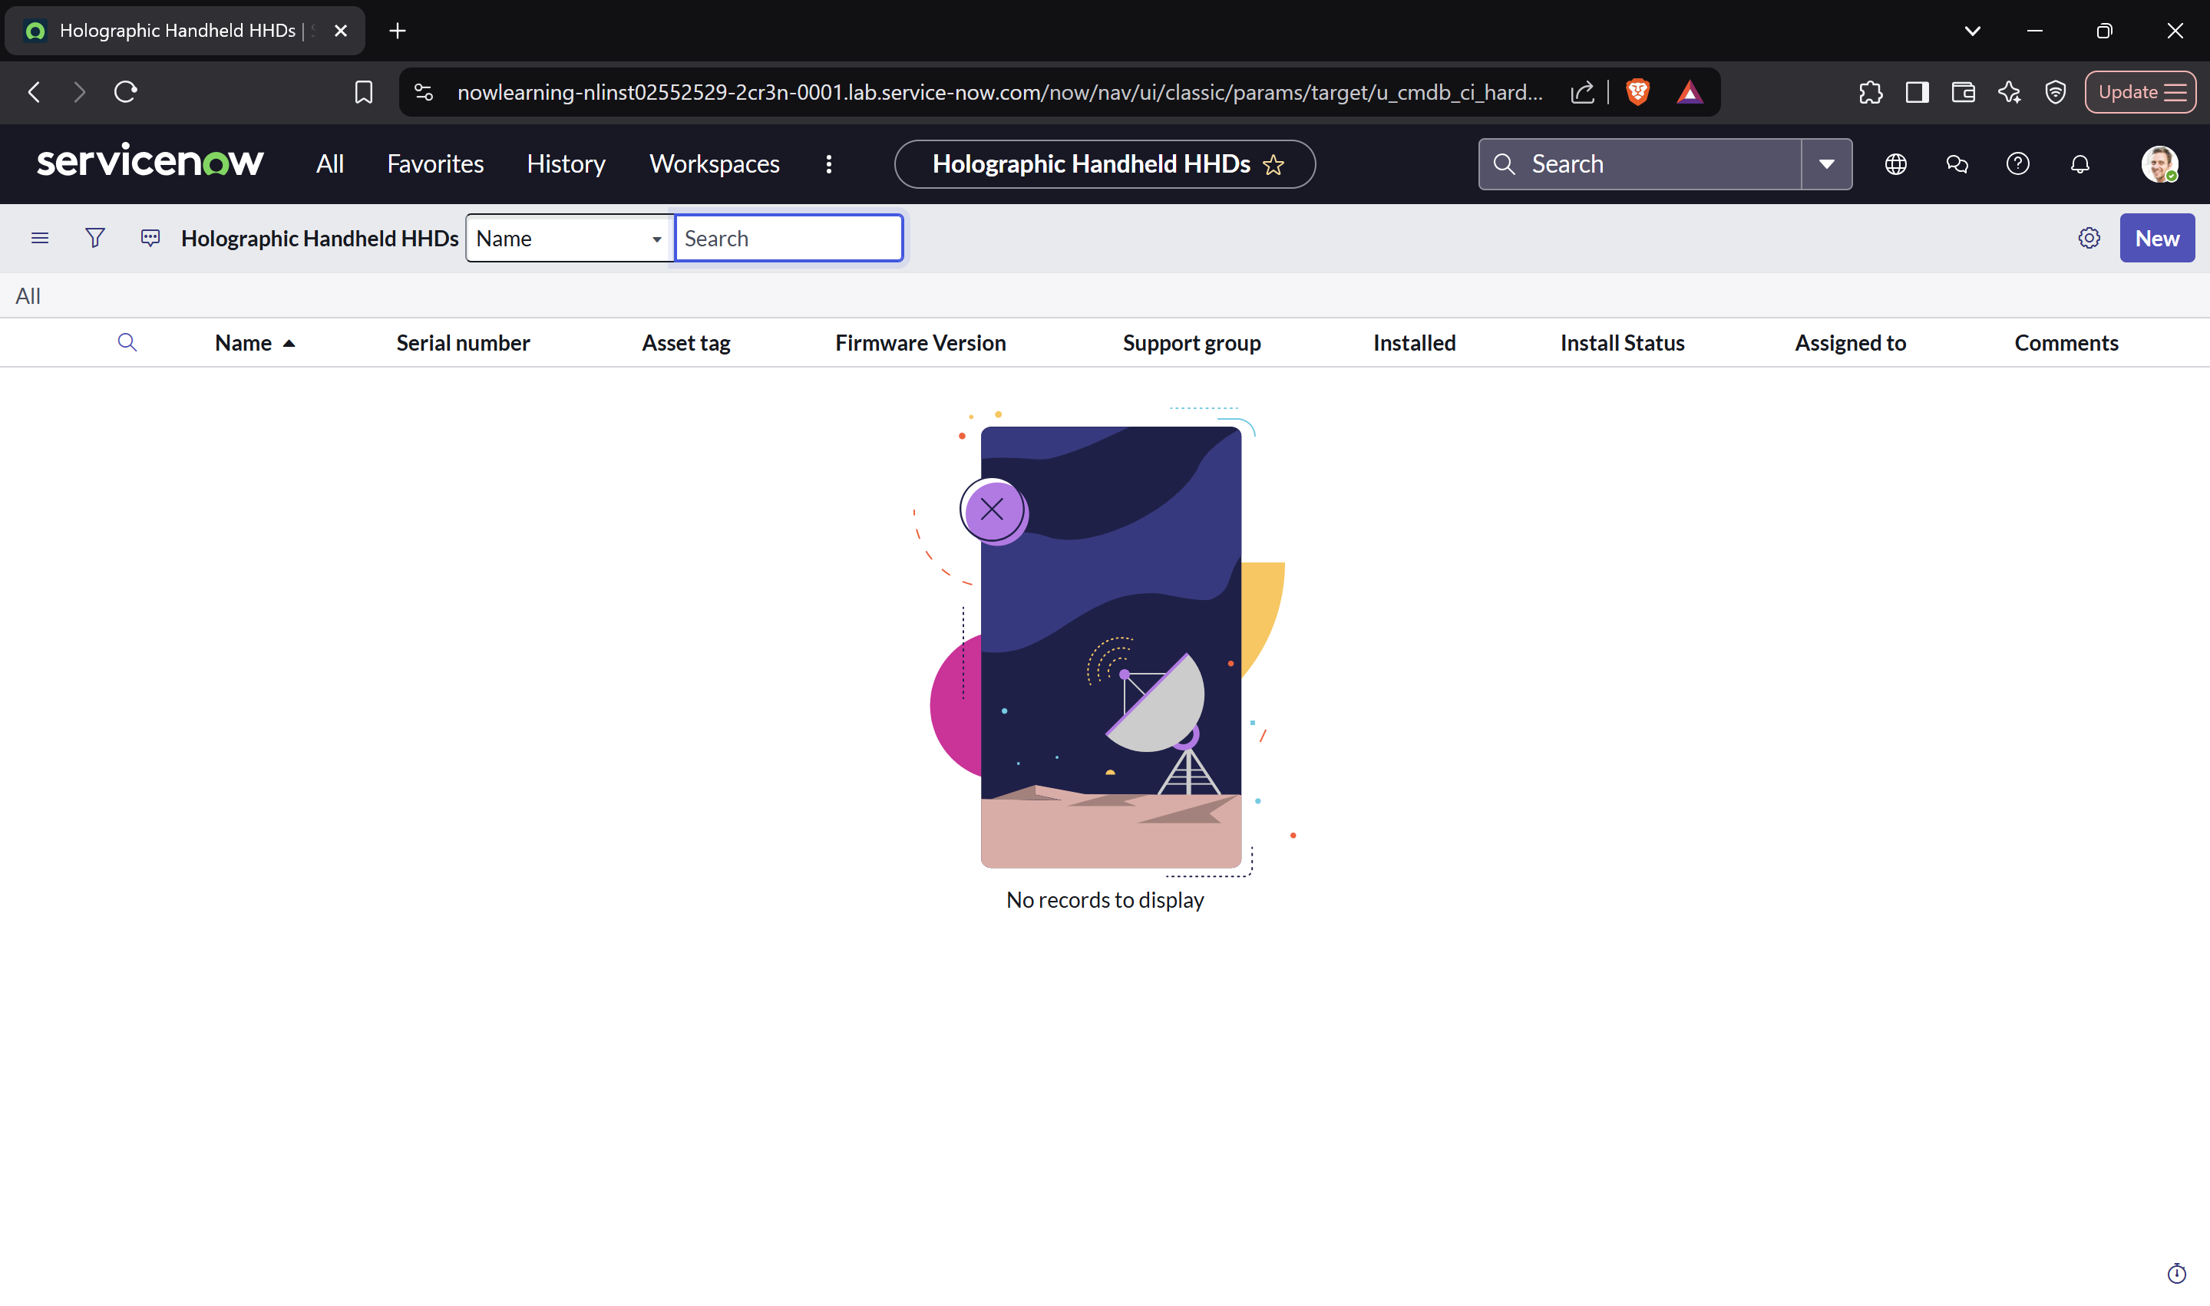

**Section 2: Configure Infinity HHD Form**

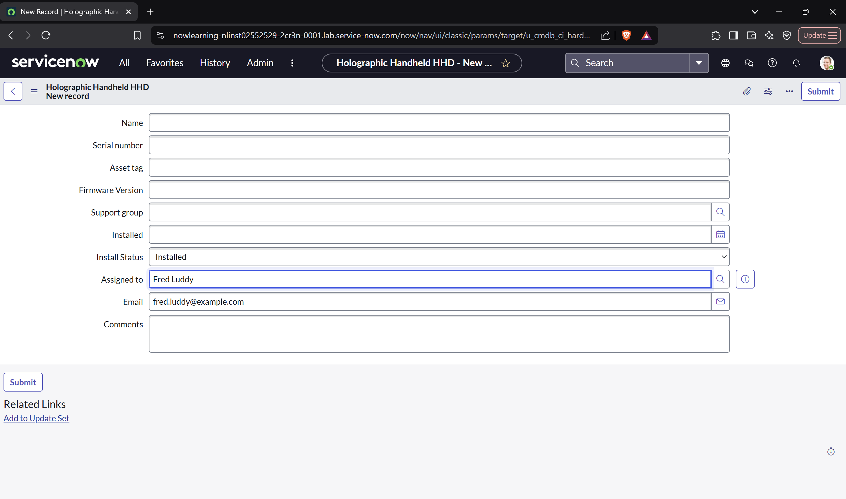

**Section 3: Update Application Menu**

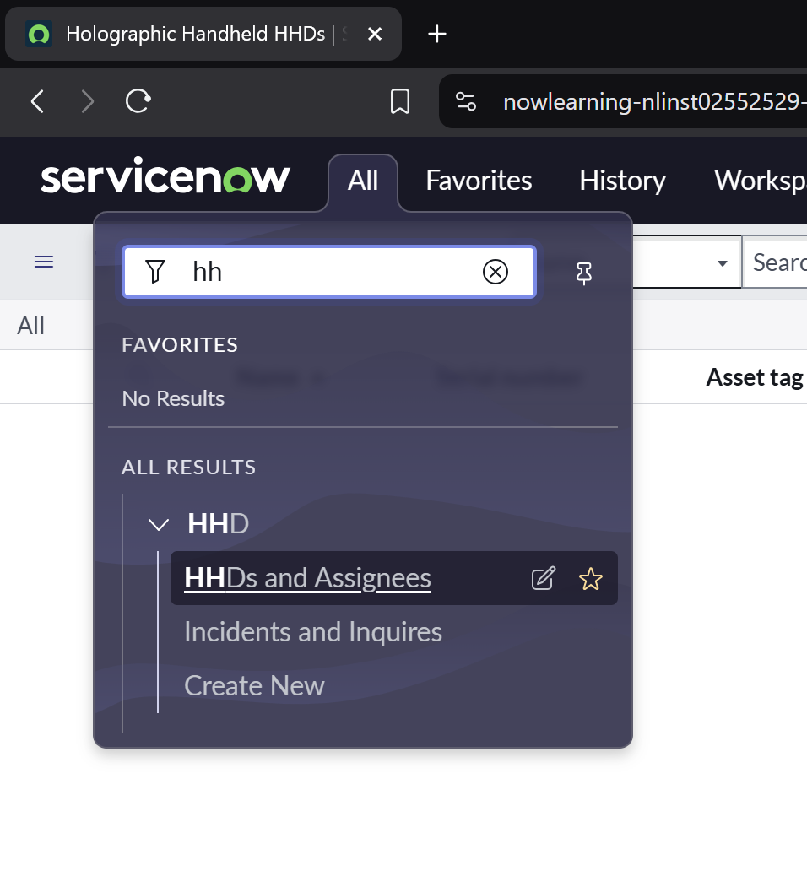

**Lab 4.2 Create Access Controls**

**Section 1: Provide Application Menu and Module Access**

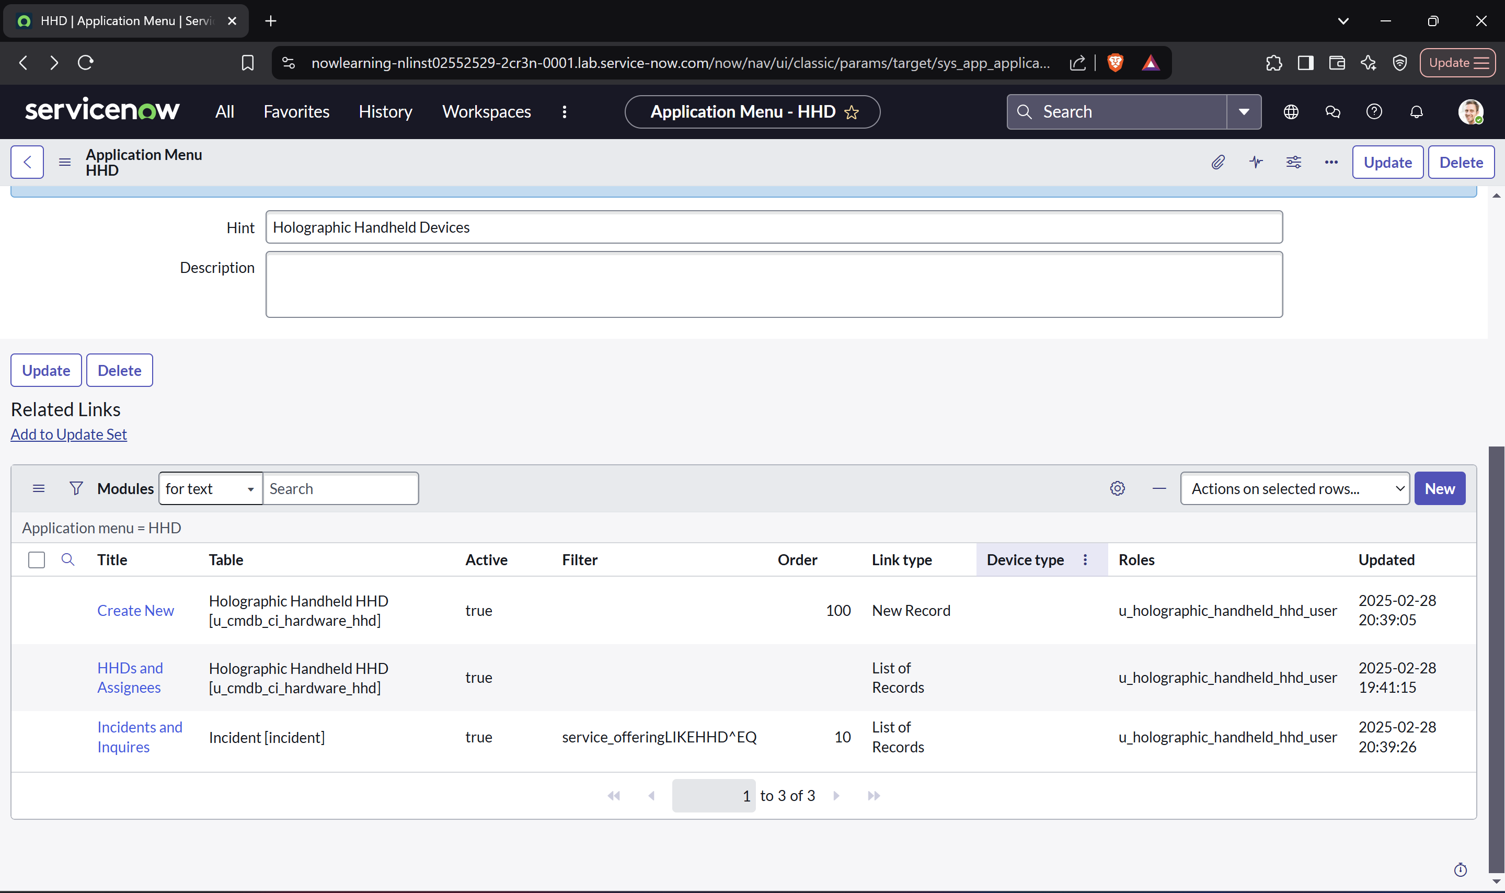

**Section 2: Grant Roles to Support Groups**

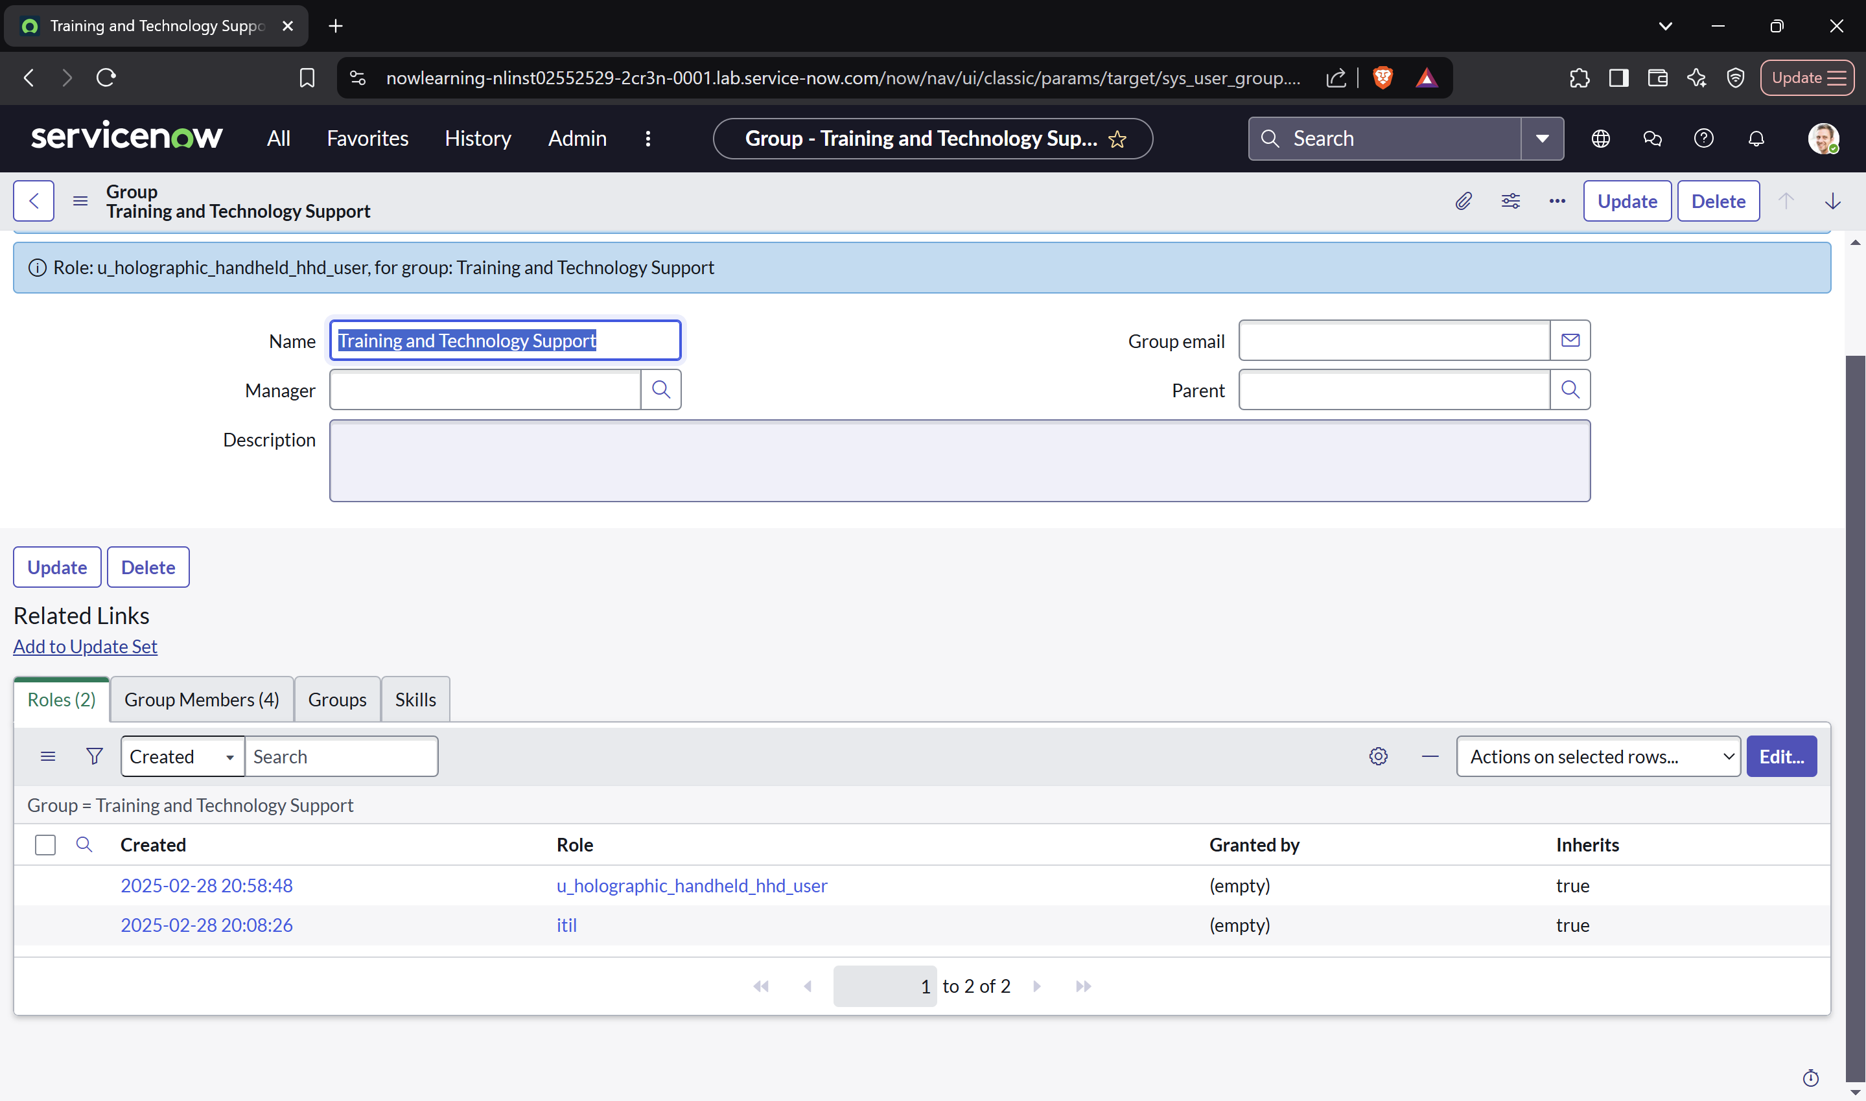

**Section 3: Test the Visibility Settings**

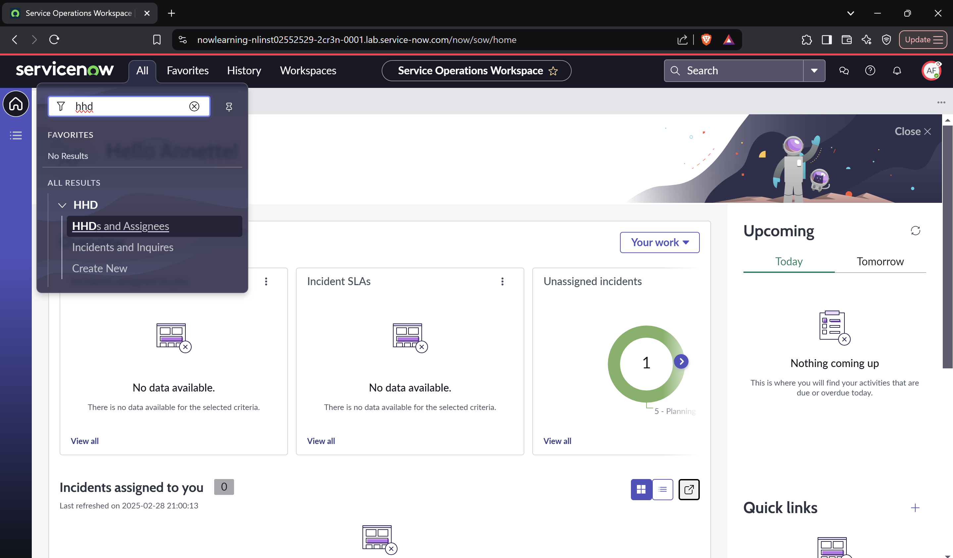

**Section 4: Establish Access Control Rules for Incident**

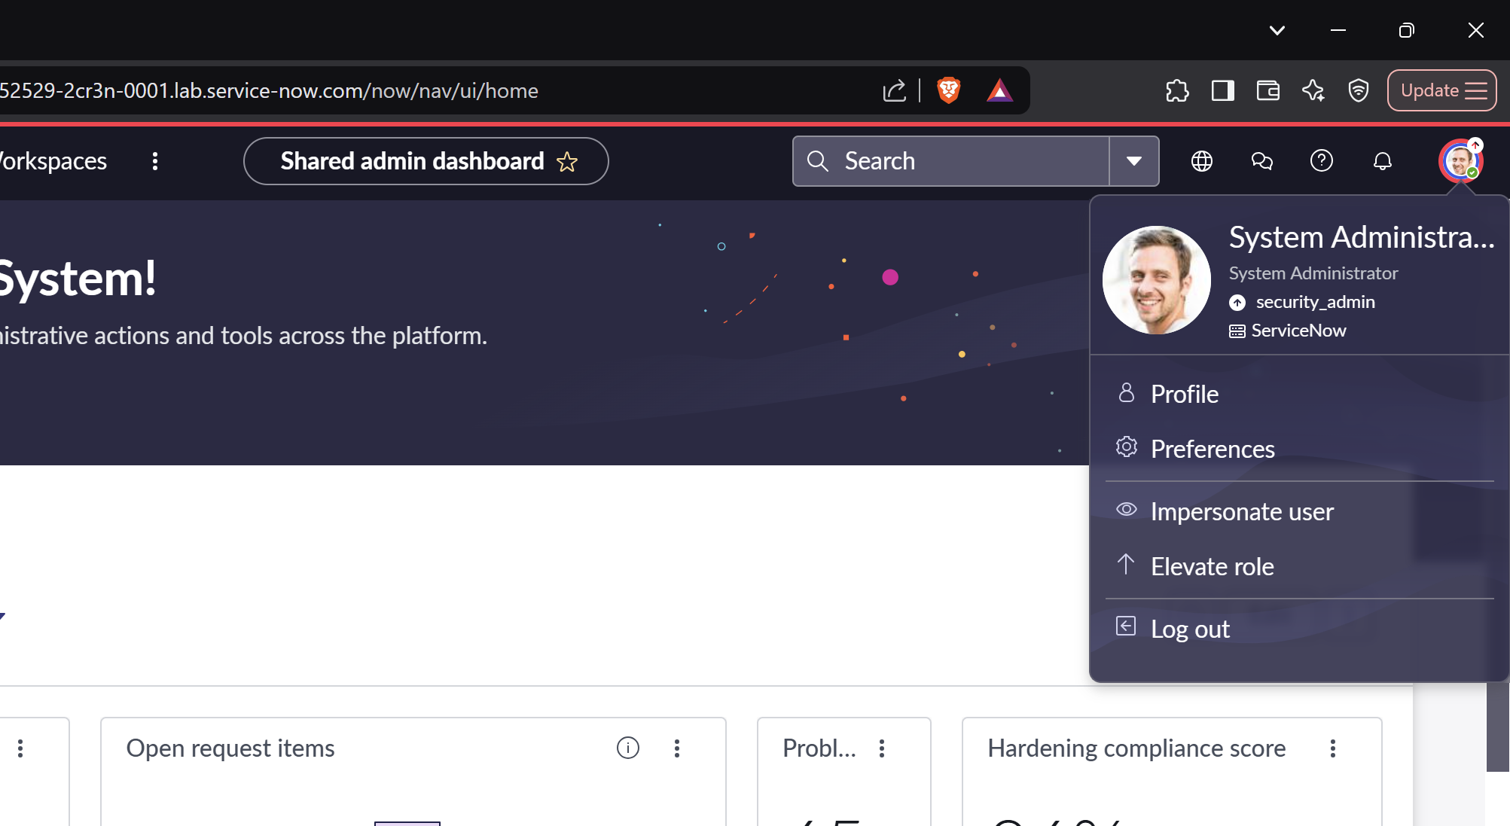

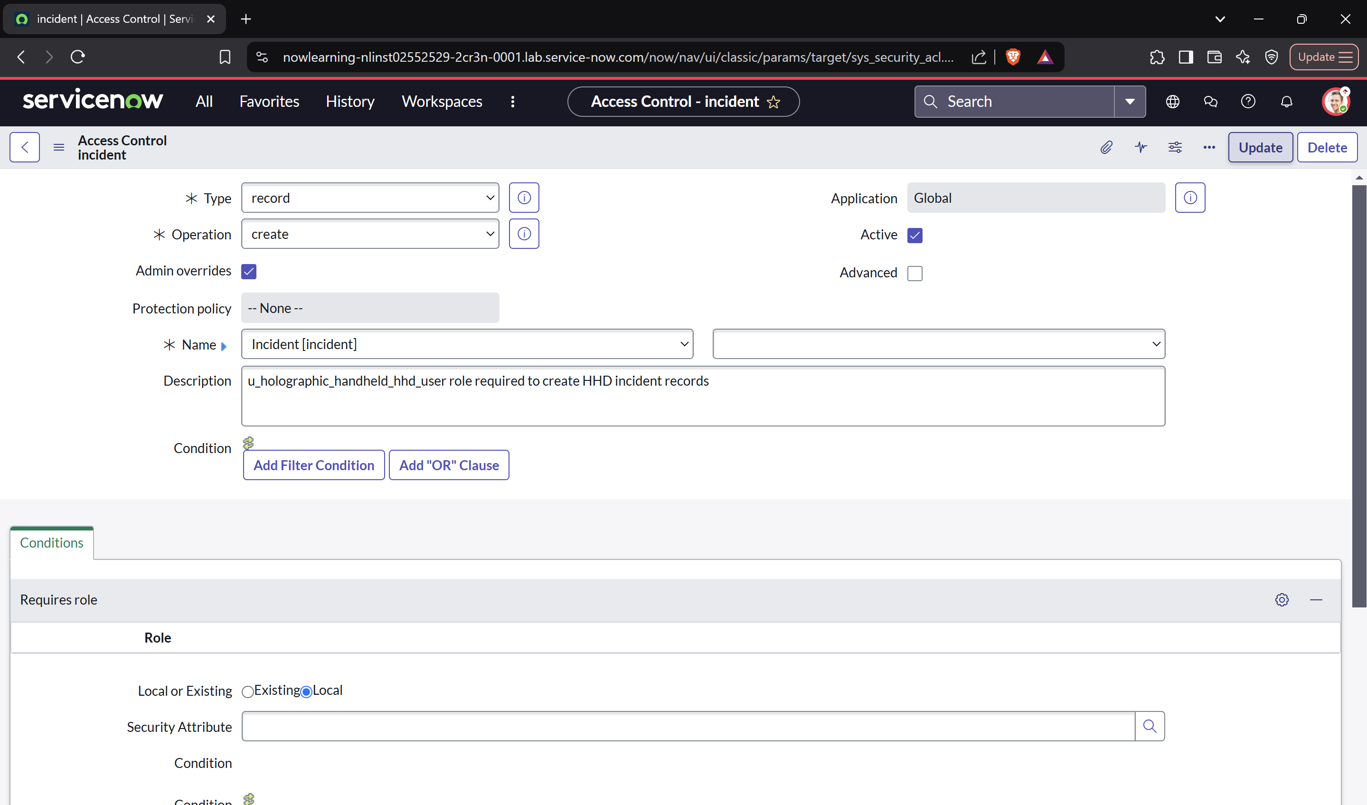

**Section 5: Create an Access Control Rule for Asset Tag**



**Section 6: Grant the Role for Updating Asset Tags**

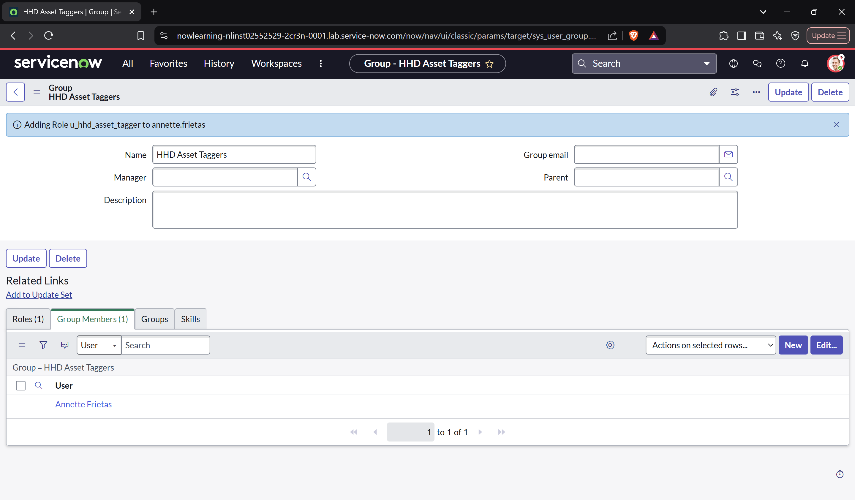

**Section 7: Test the Asset Tag Settings**

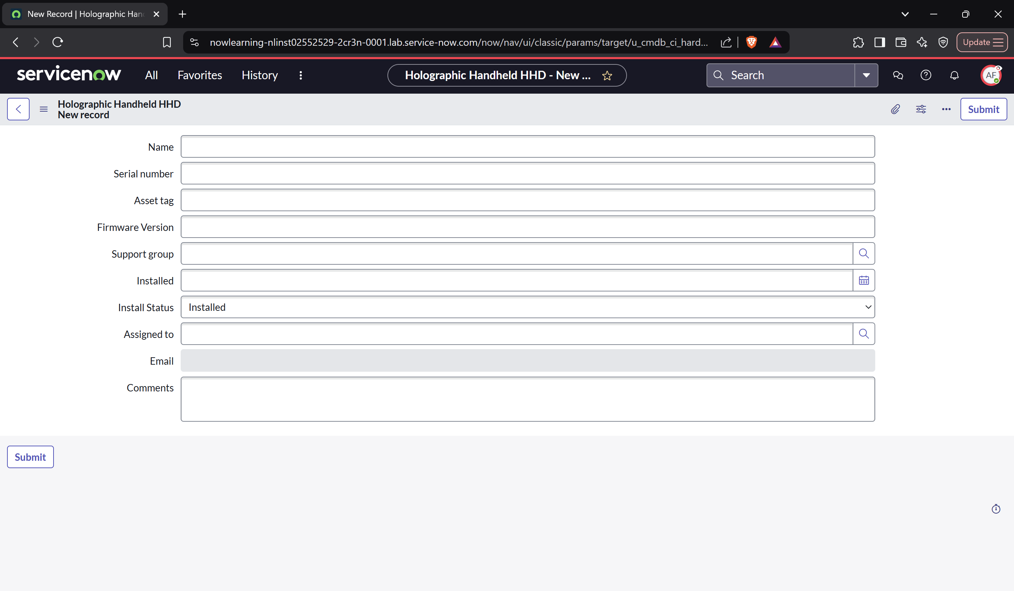

**Lab 4.3 Import HHD Hardware Data**

**Section 1: Initial Data Load**

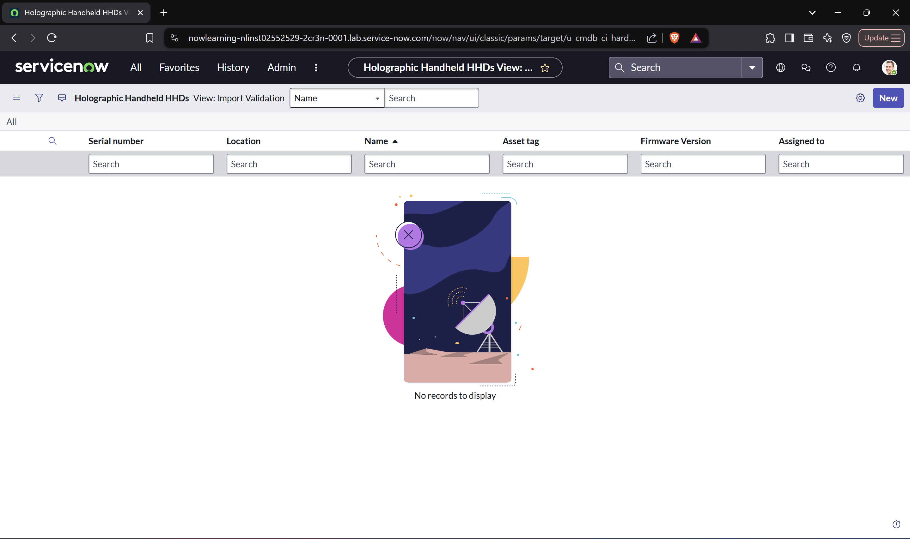

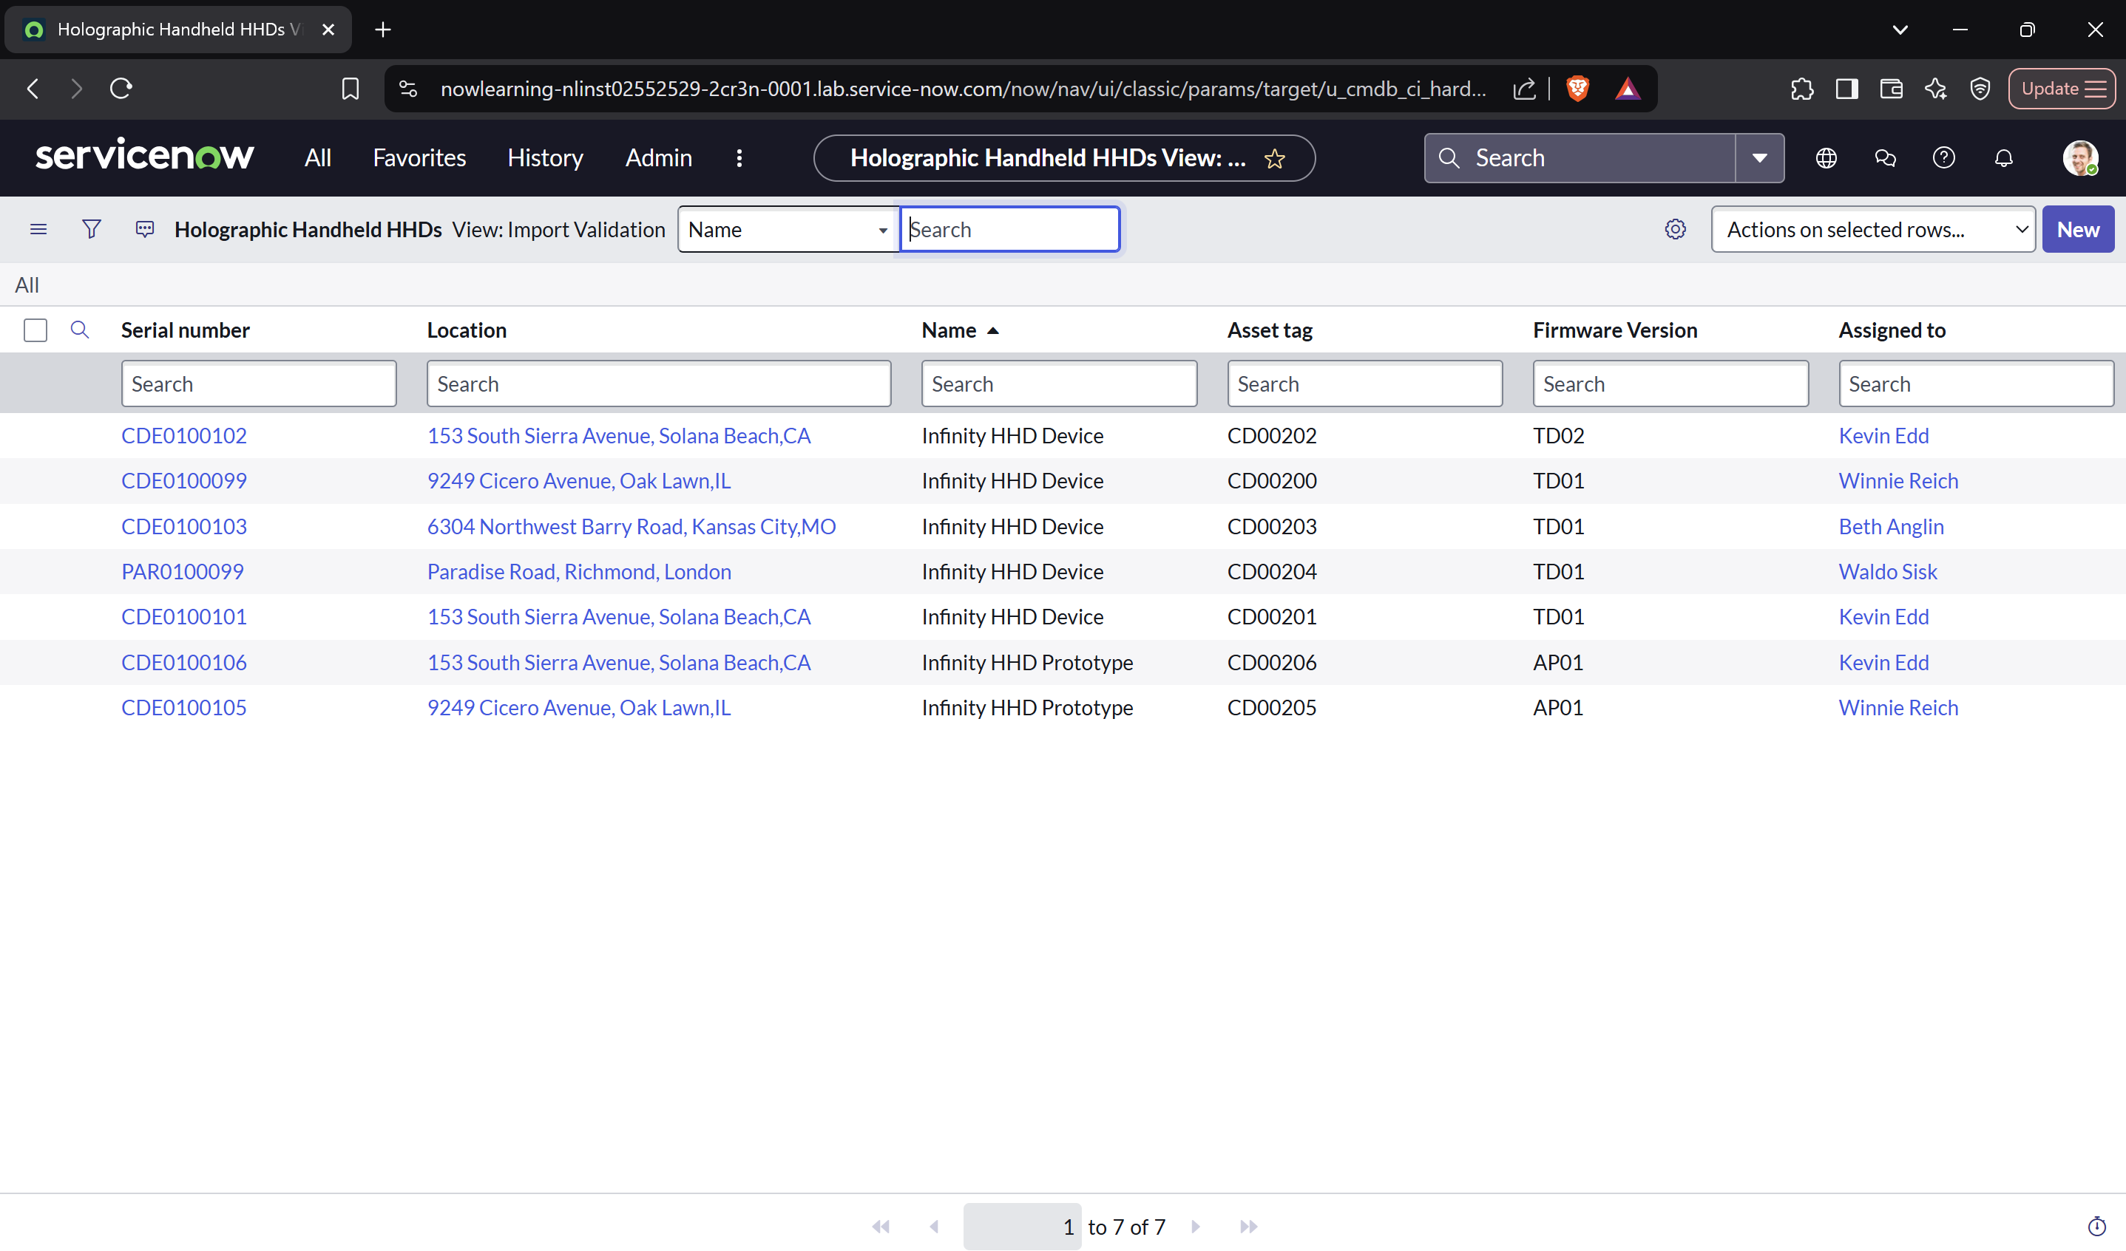

**Section 2: Incremental Data Load**

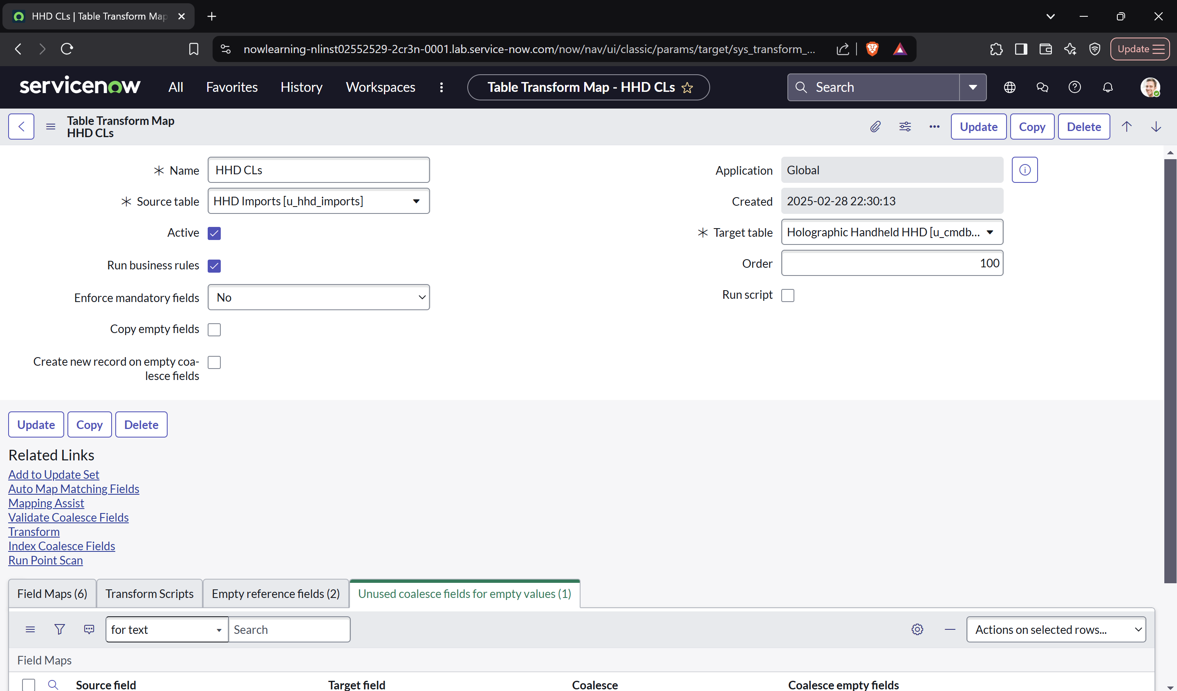

**Section 3: Clean Up Import Set Tables**

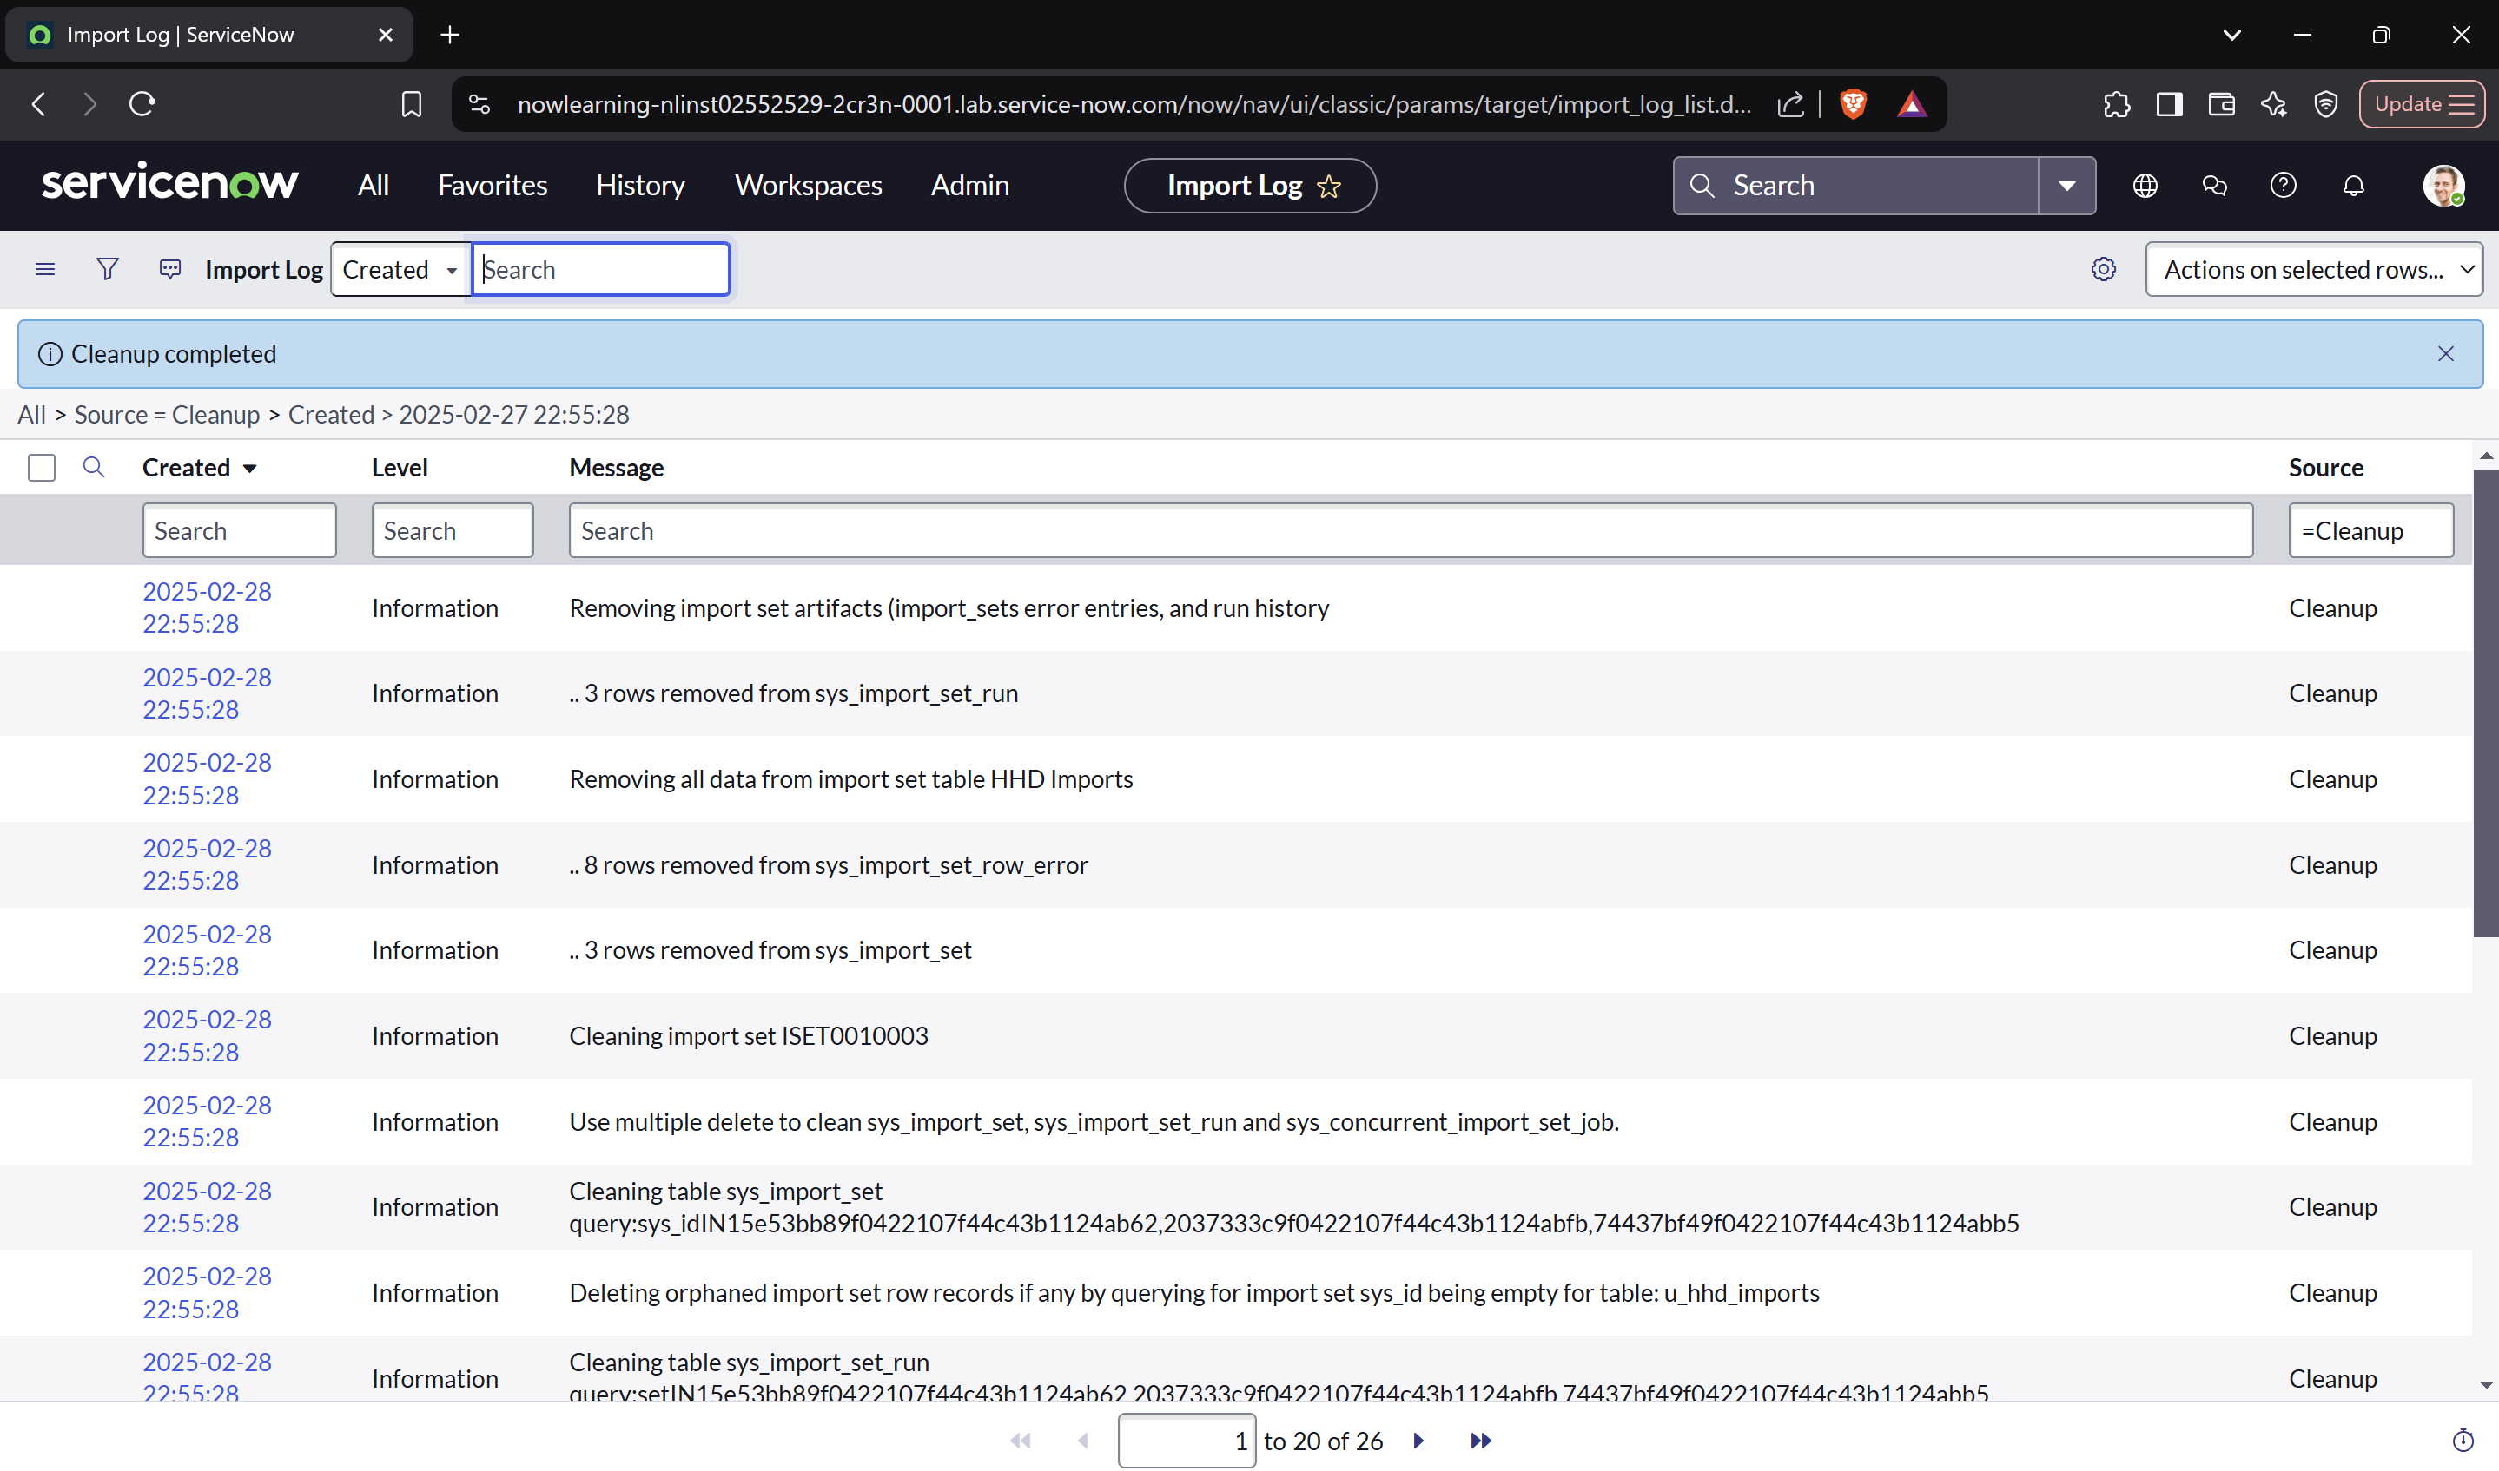

**Lab 4.4 Explore Data Structures, CMDB, and CI Relationships**

**Section 1: Explore Data Structures**

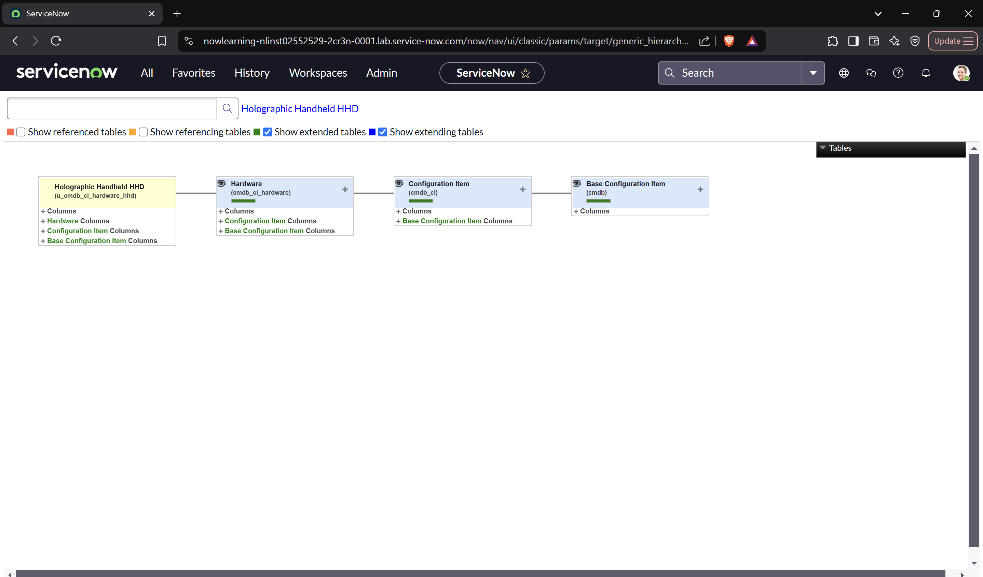

**Section 2: Explore CI Class Manager - CMDB, CIs, and Relationships**

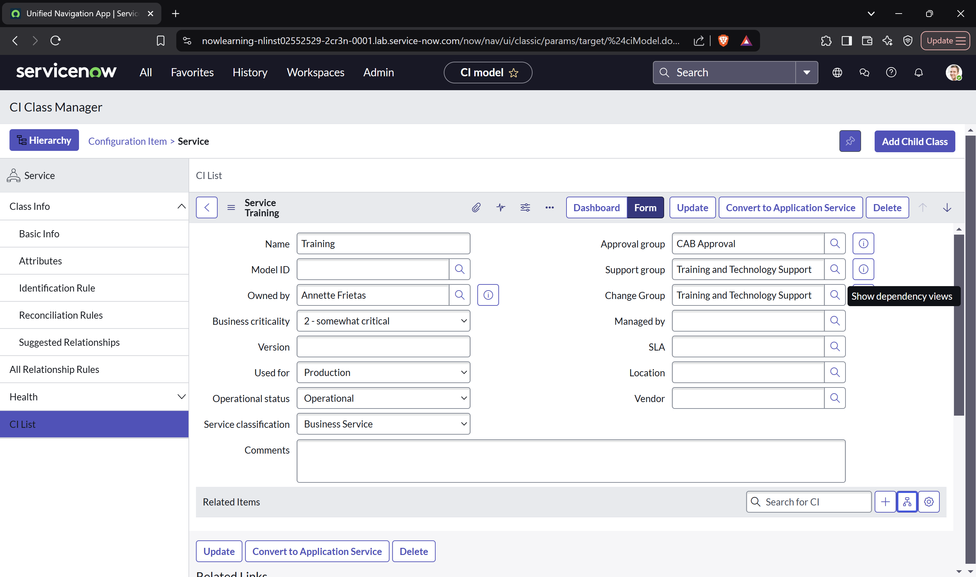

**Section 3: Create New Suggested Relationship Type**

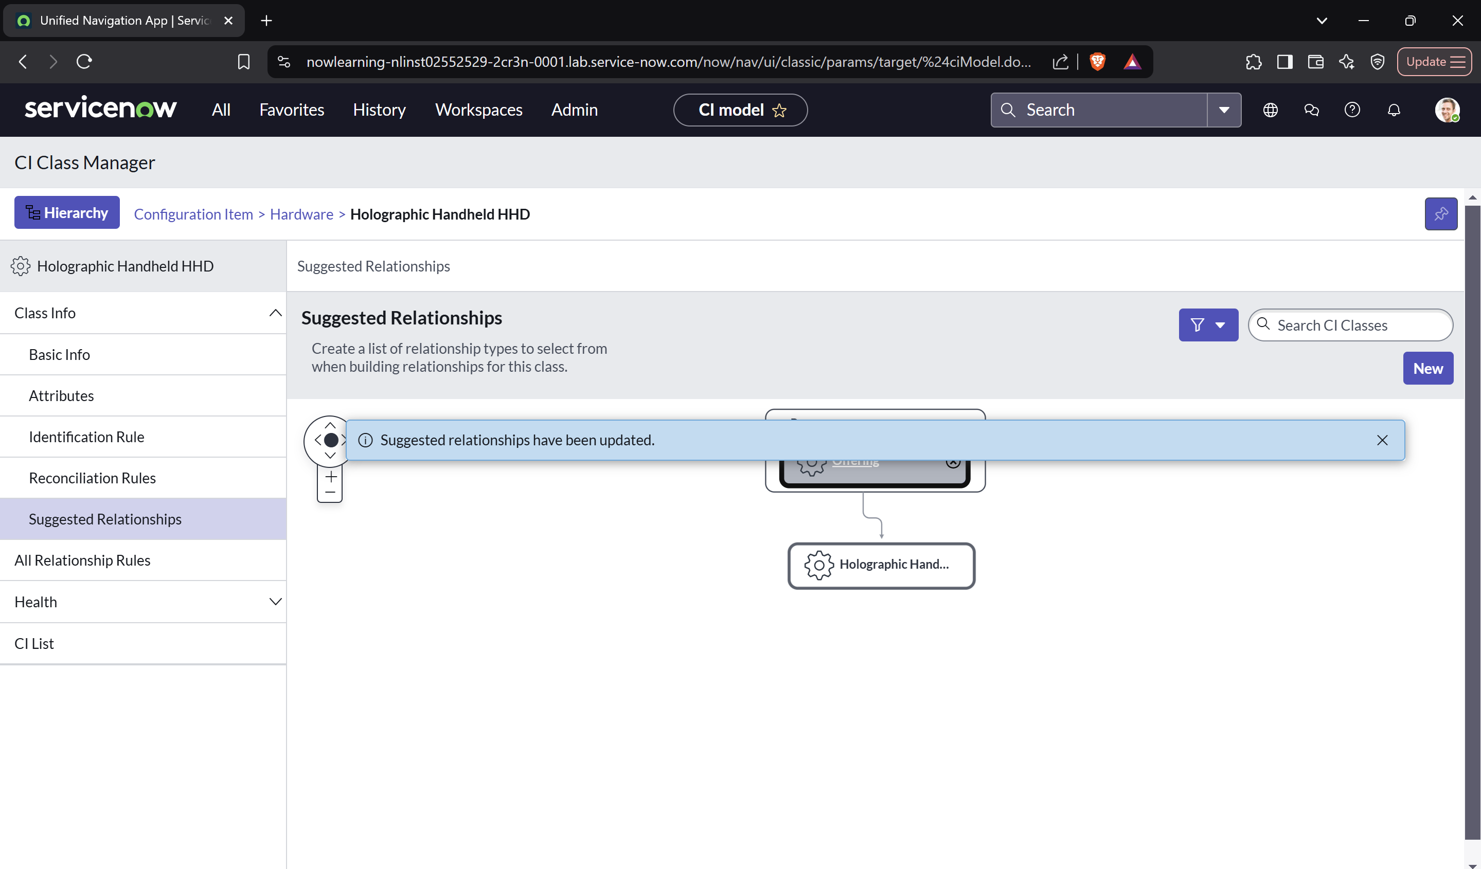

**Section 4: Associate HHD devices with Service Offering**

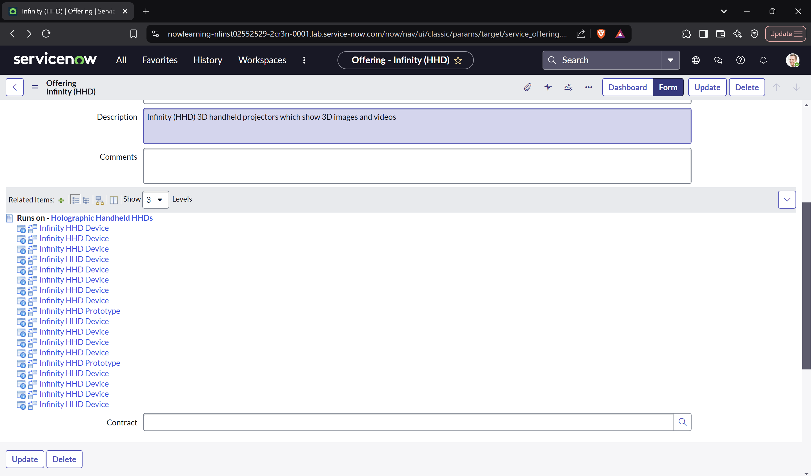

**Section 5: View Relationship from HHD CI Record**

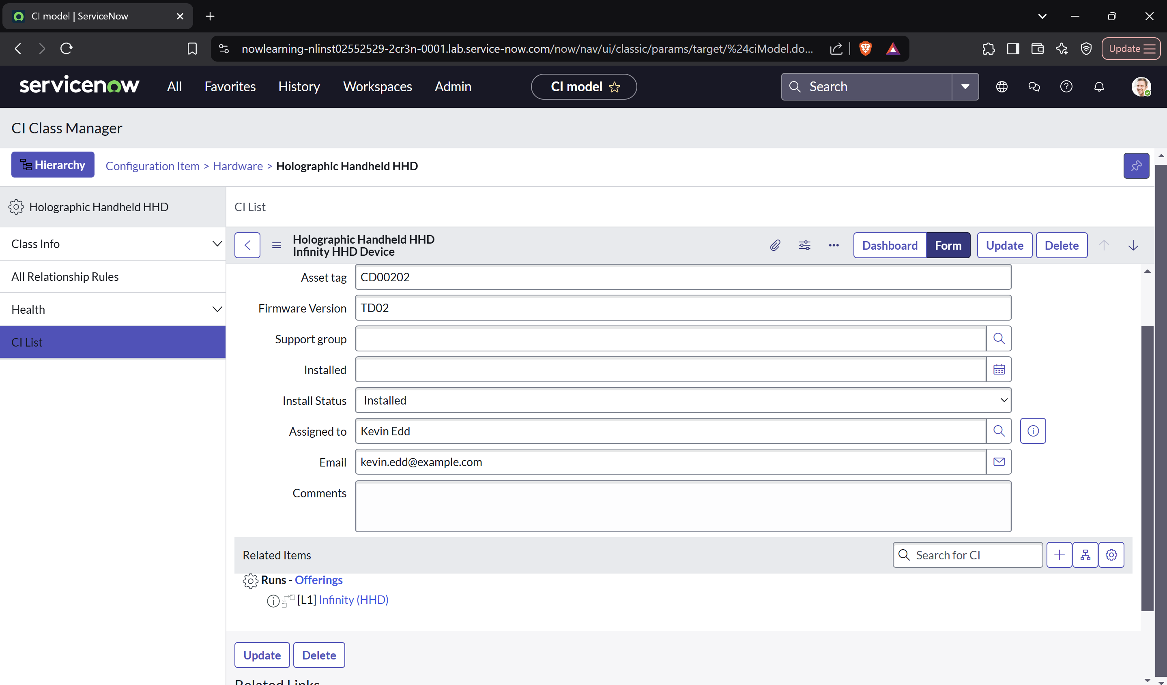

**Section 6: Verify the Ability to Use the CIs in the Incident Form (Classic)**

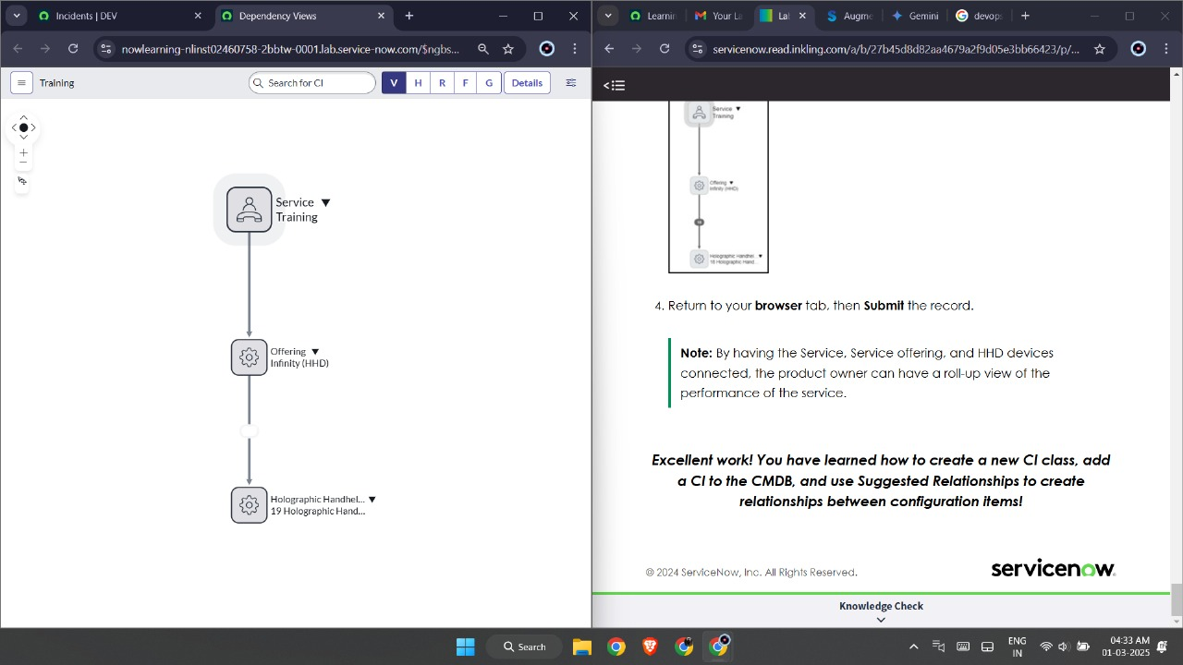

**Lab 5.1: Manage Knowledge Base and Create Articles**

**Section 1 :**



**Section 2:**





**Section 3 :**



**Section 4 :**

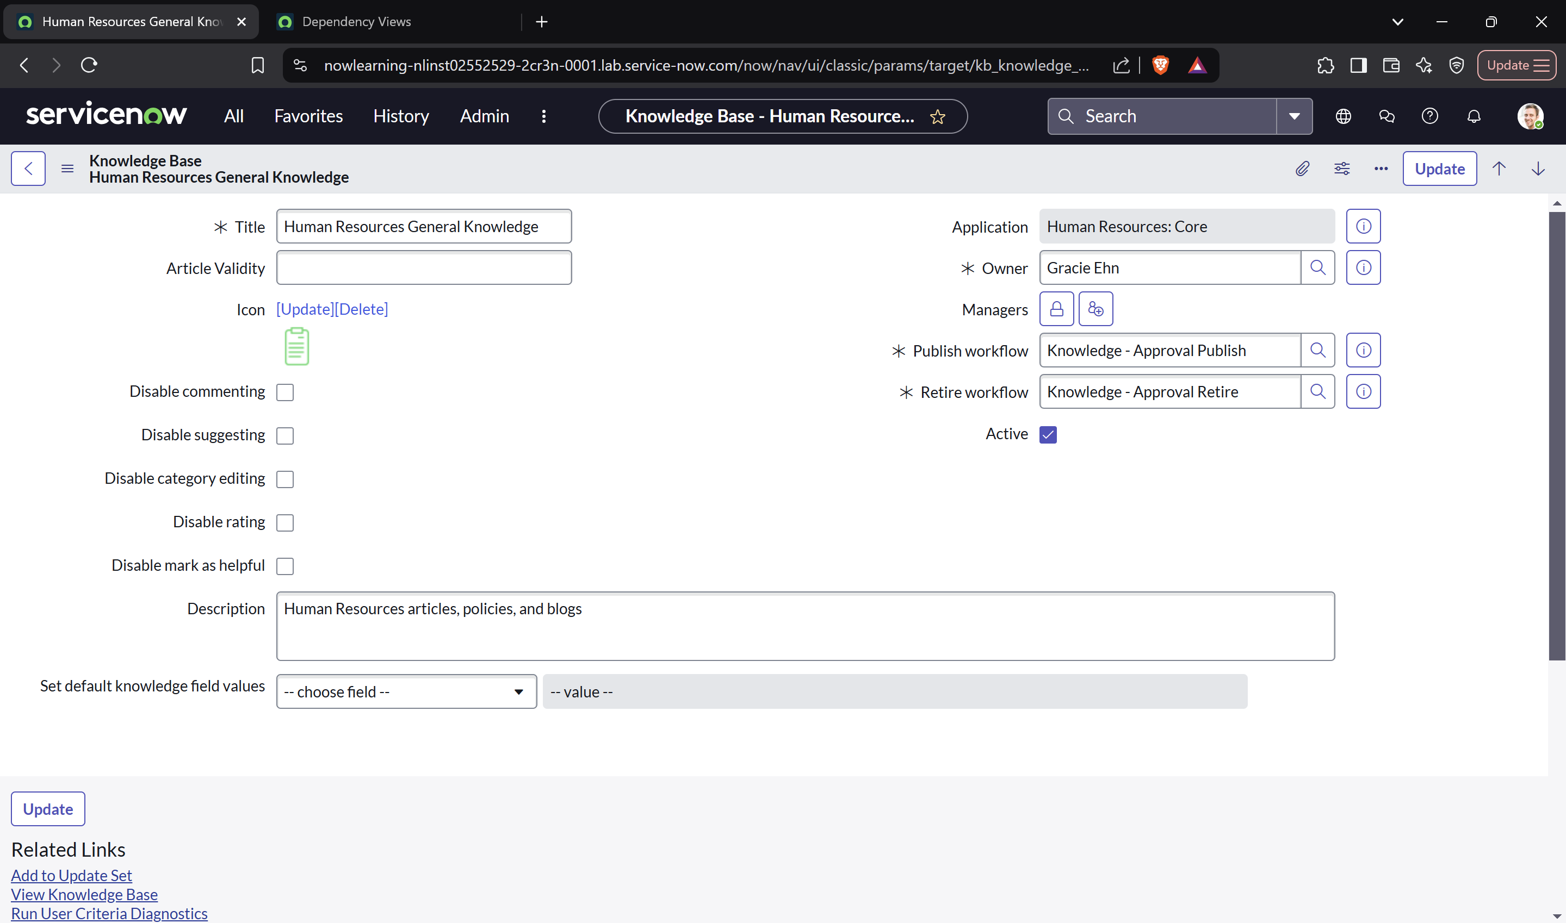

**Section 5:**

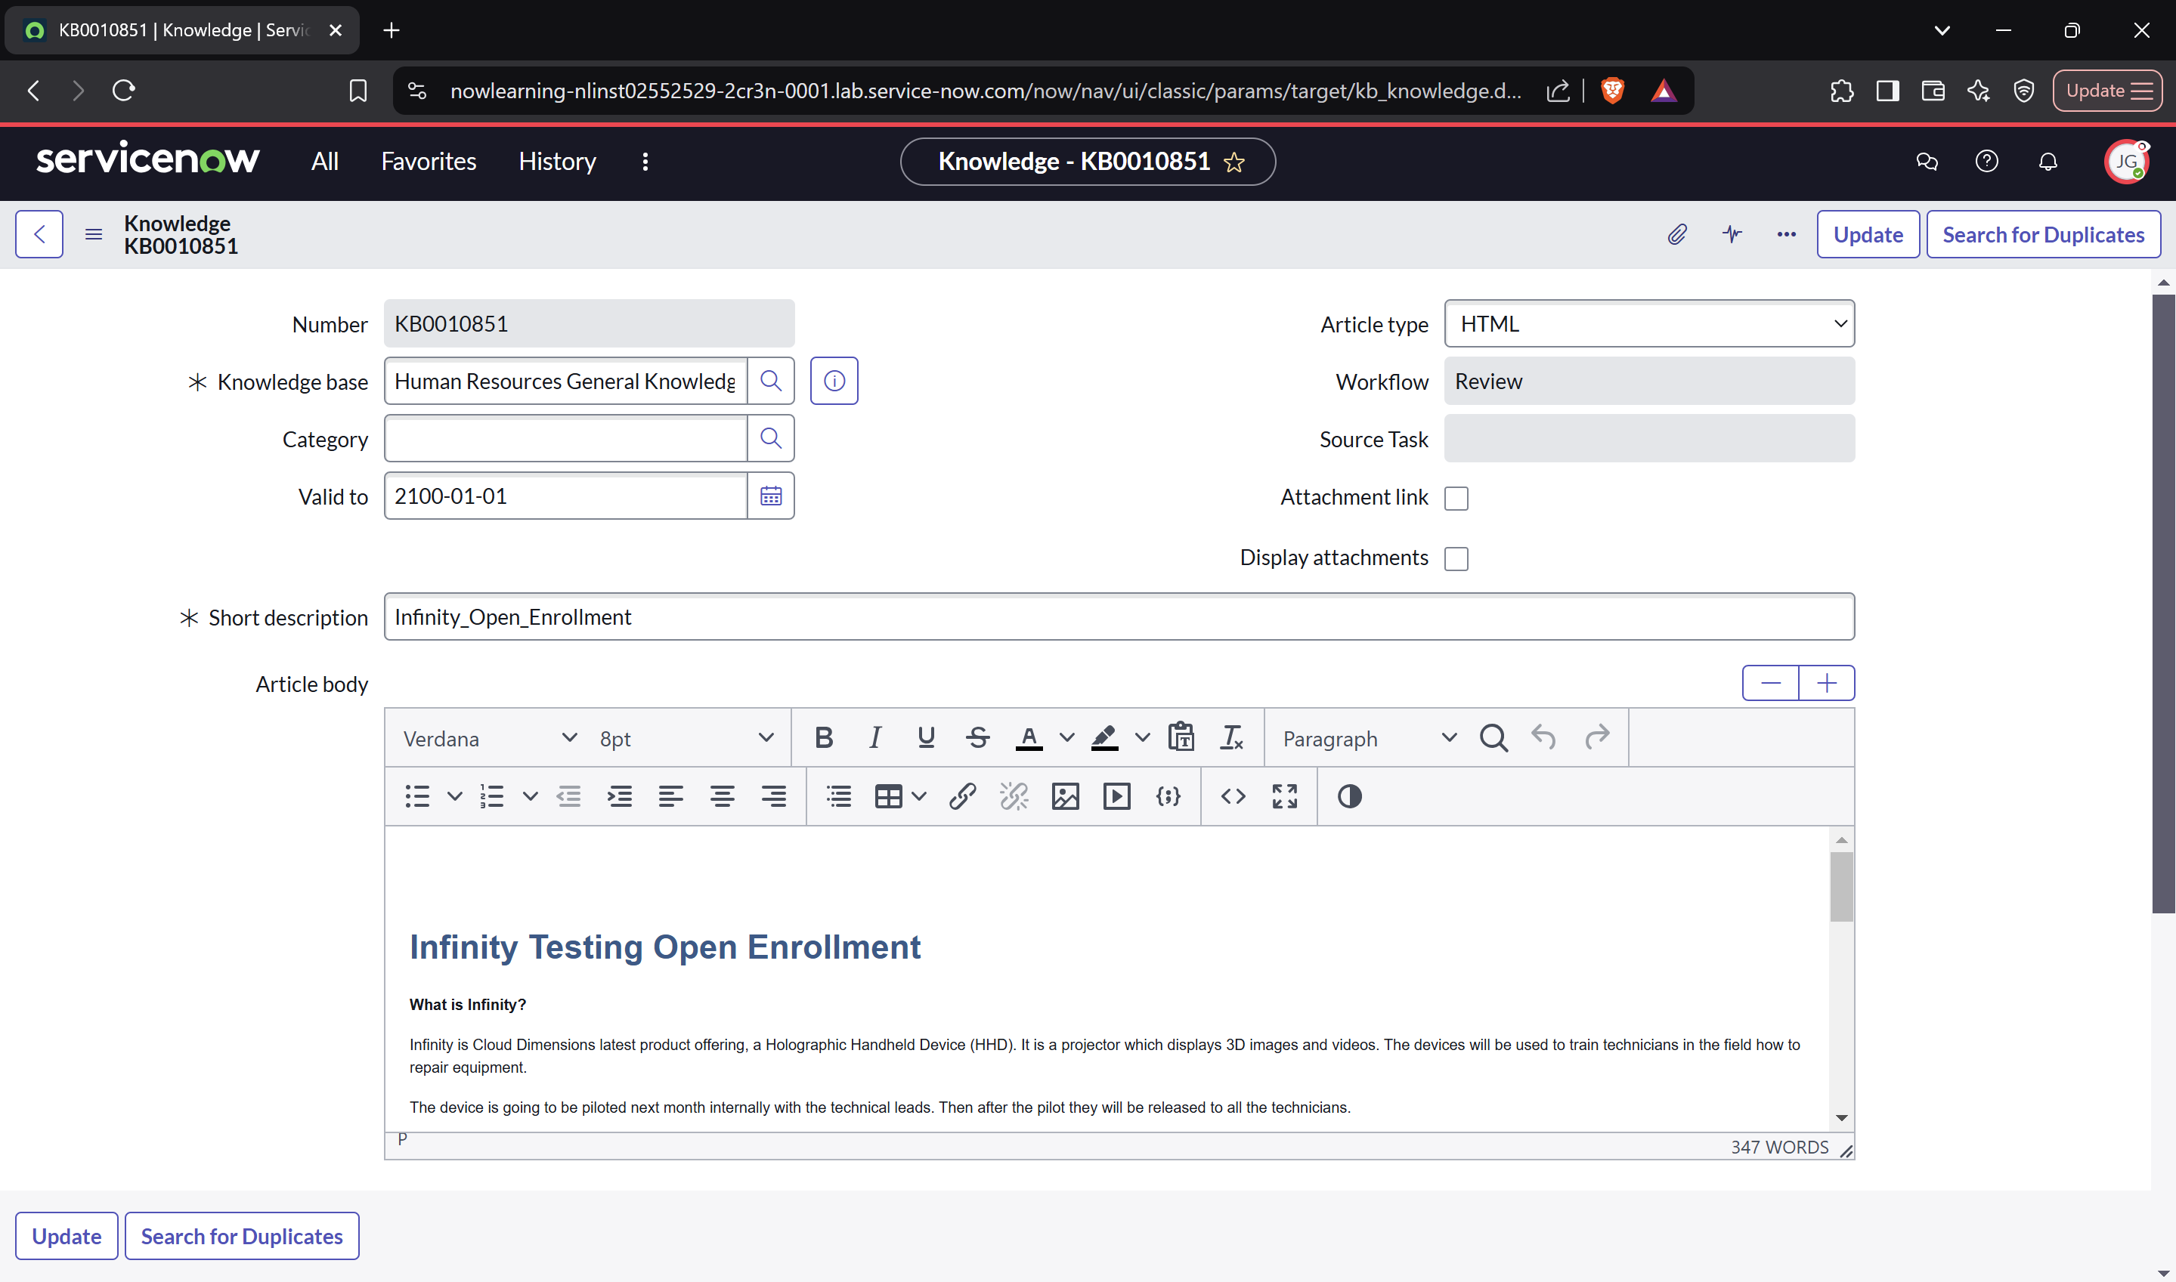

**Section 6 :**

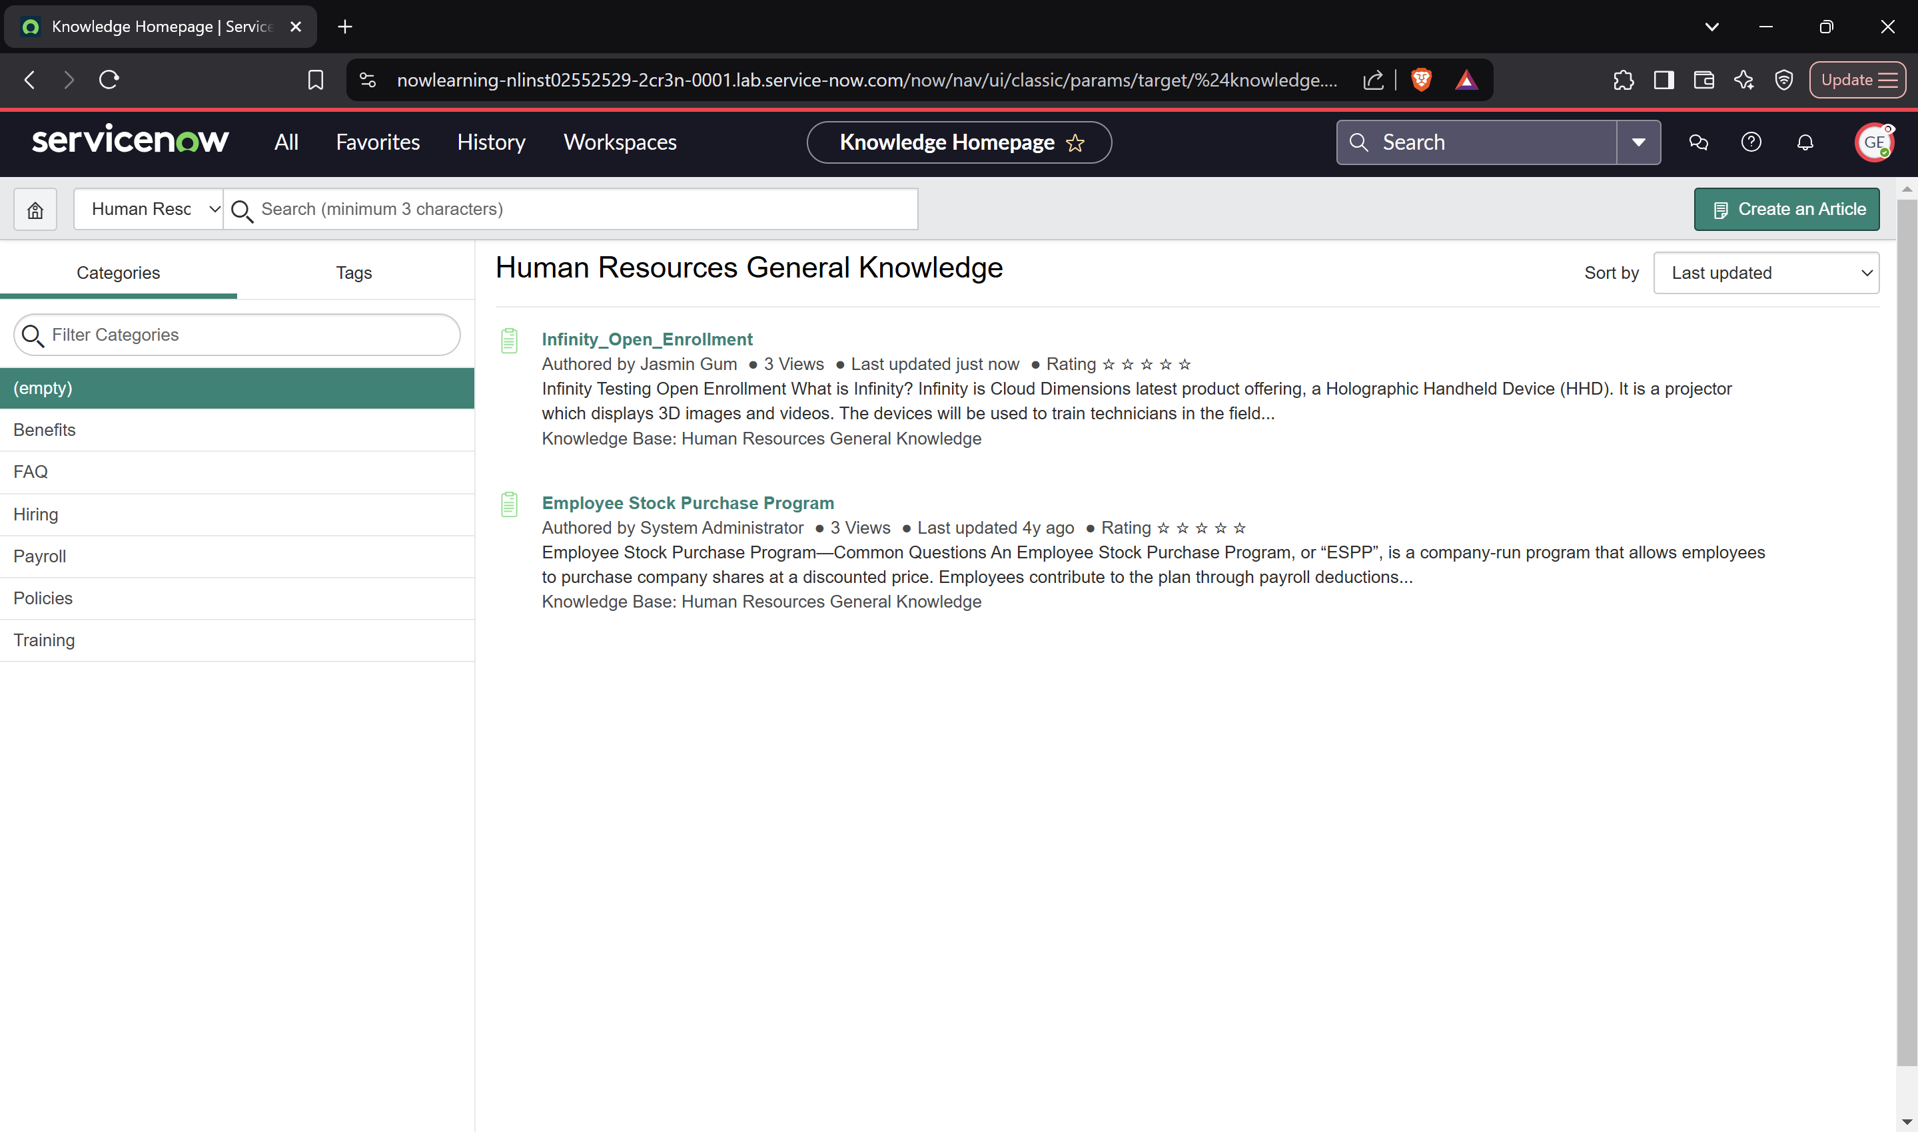

**Section 7 :**

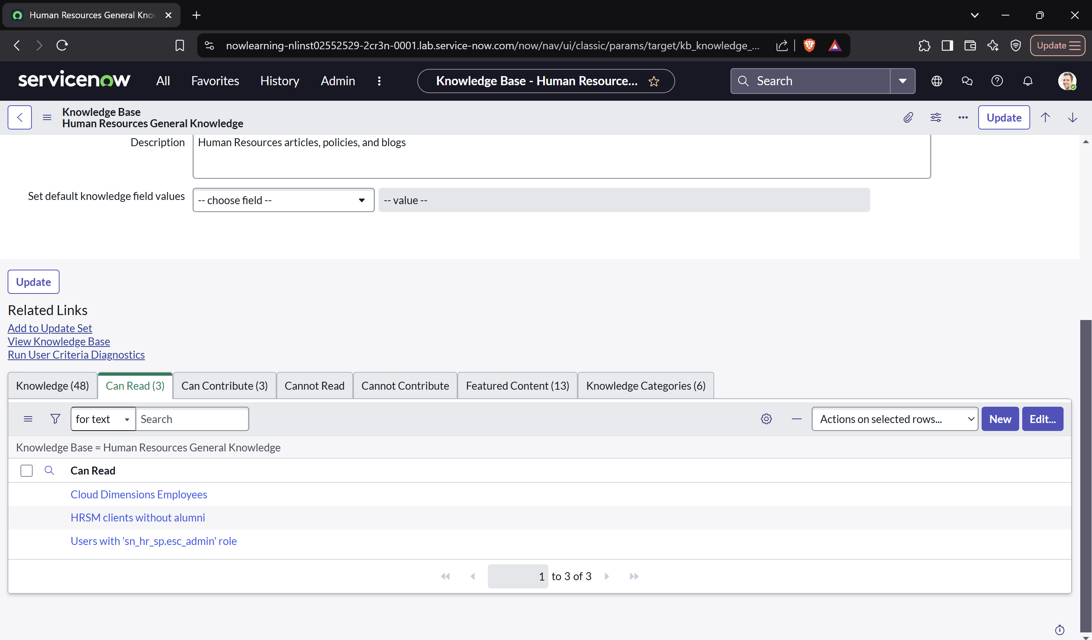

**Lab verification :**

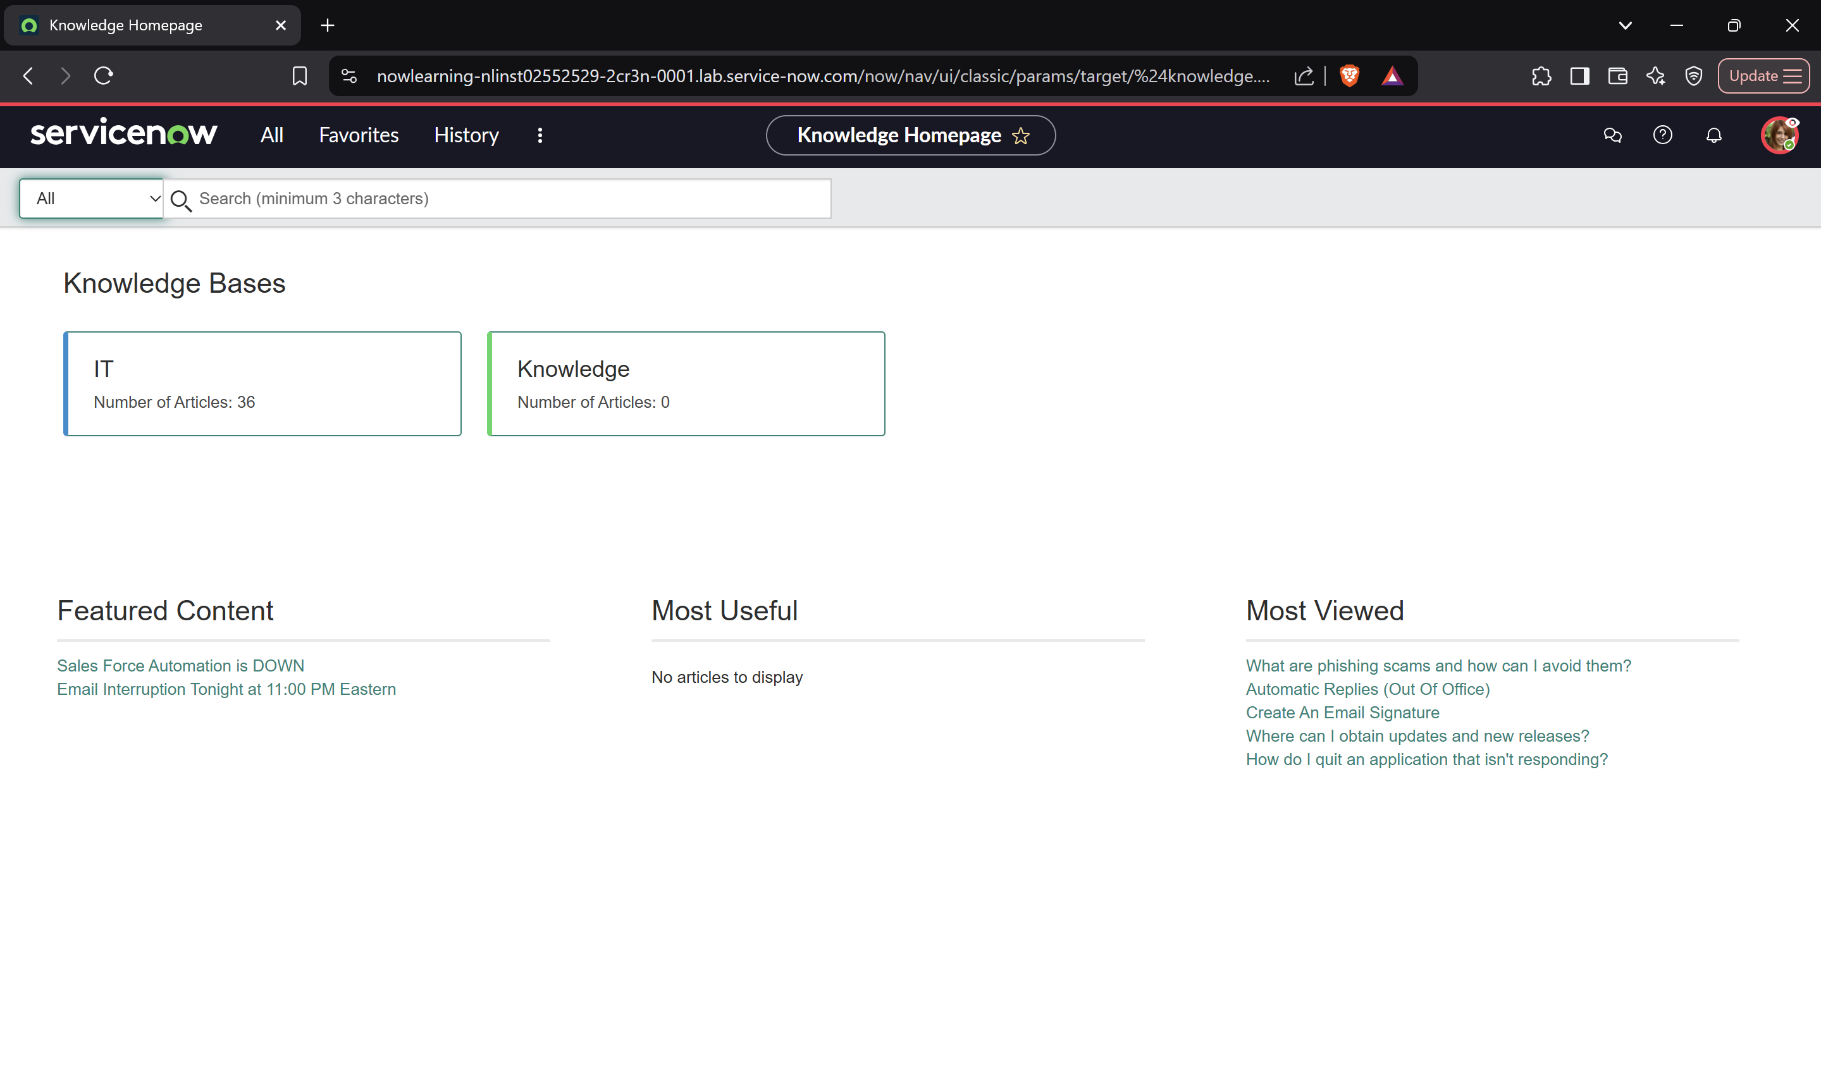

**Lab 5.2 Create a Catalog Item**

**Section 1: Assign Managers and Editors to Service Catalog**

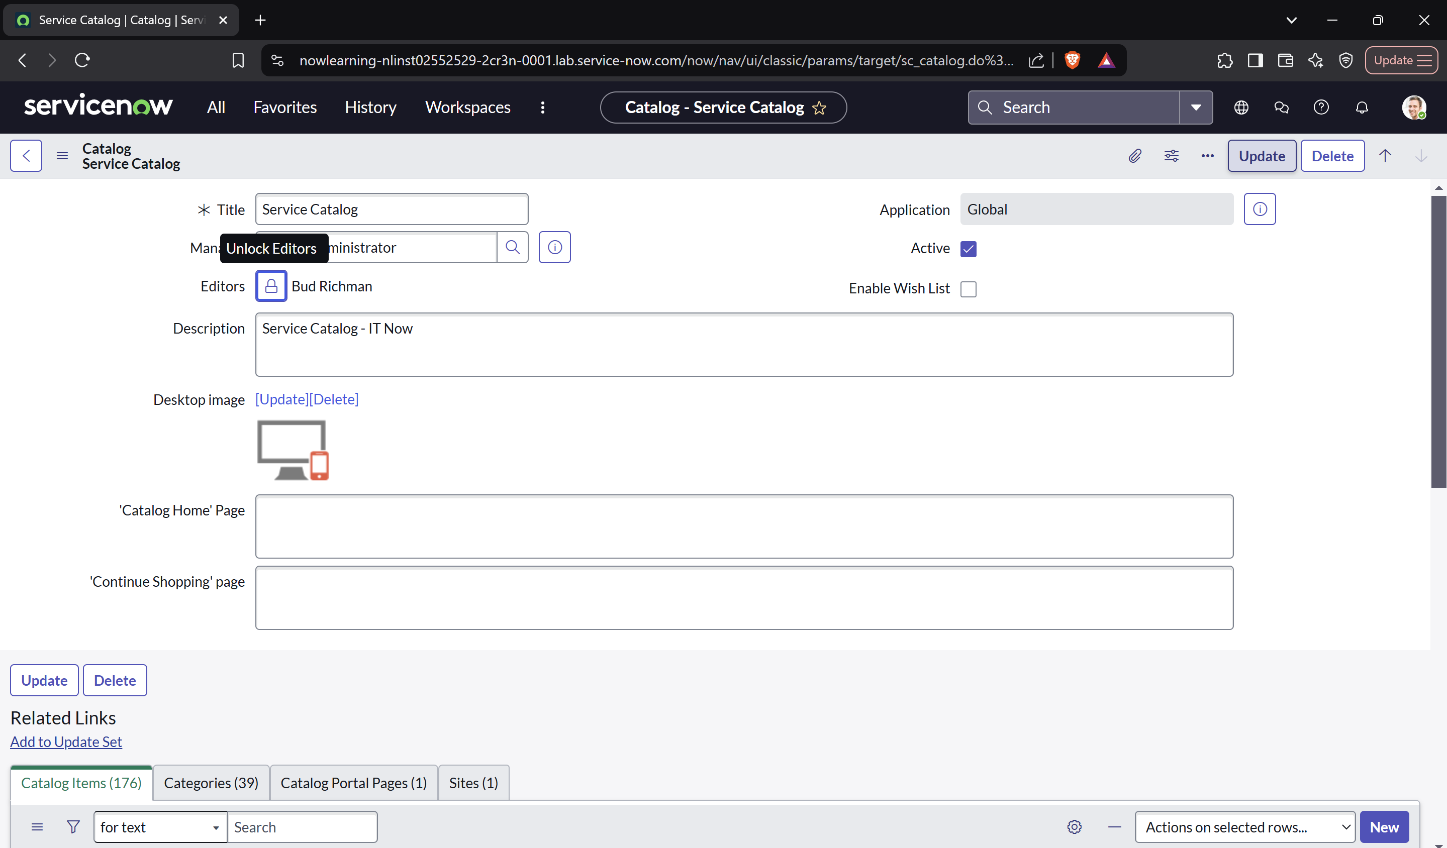

**Section 2: Create New Service Catalog Item**

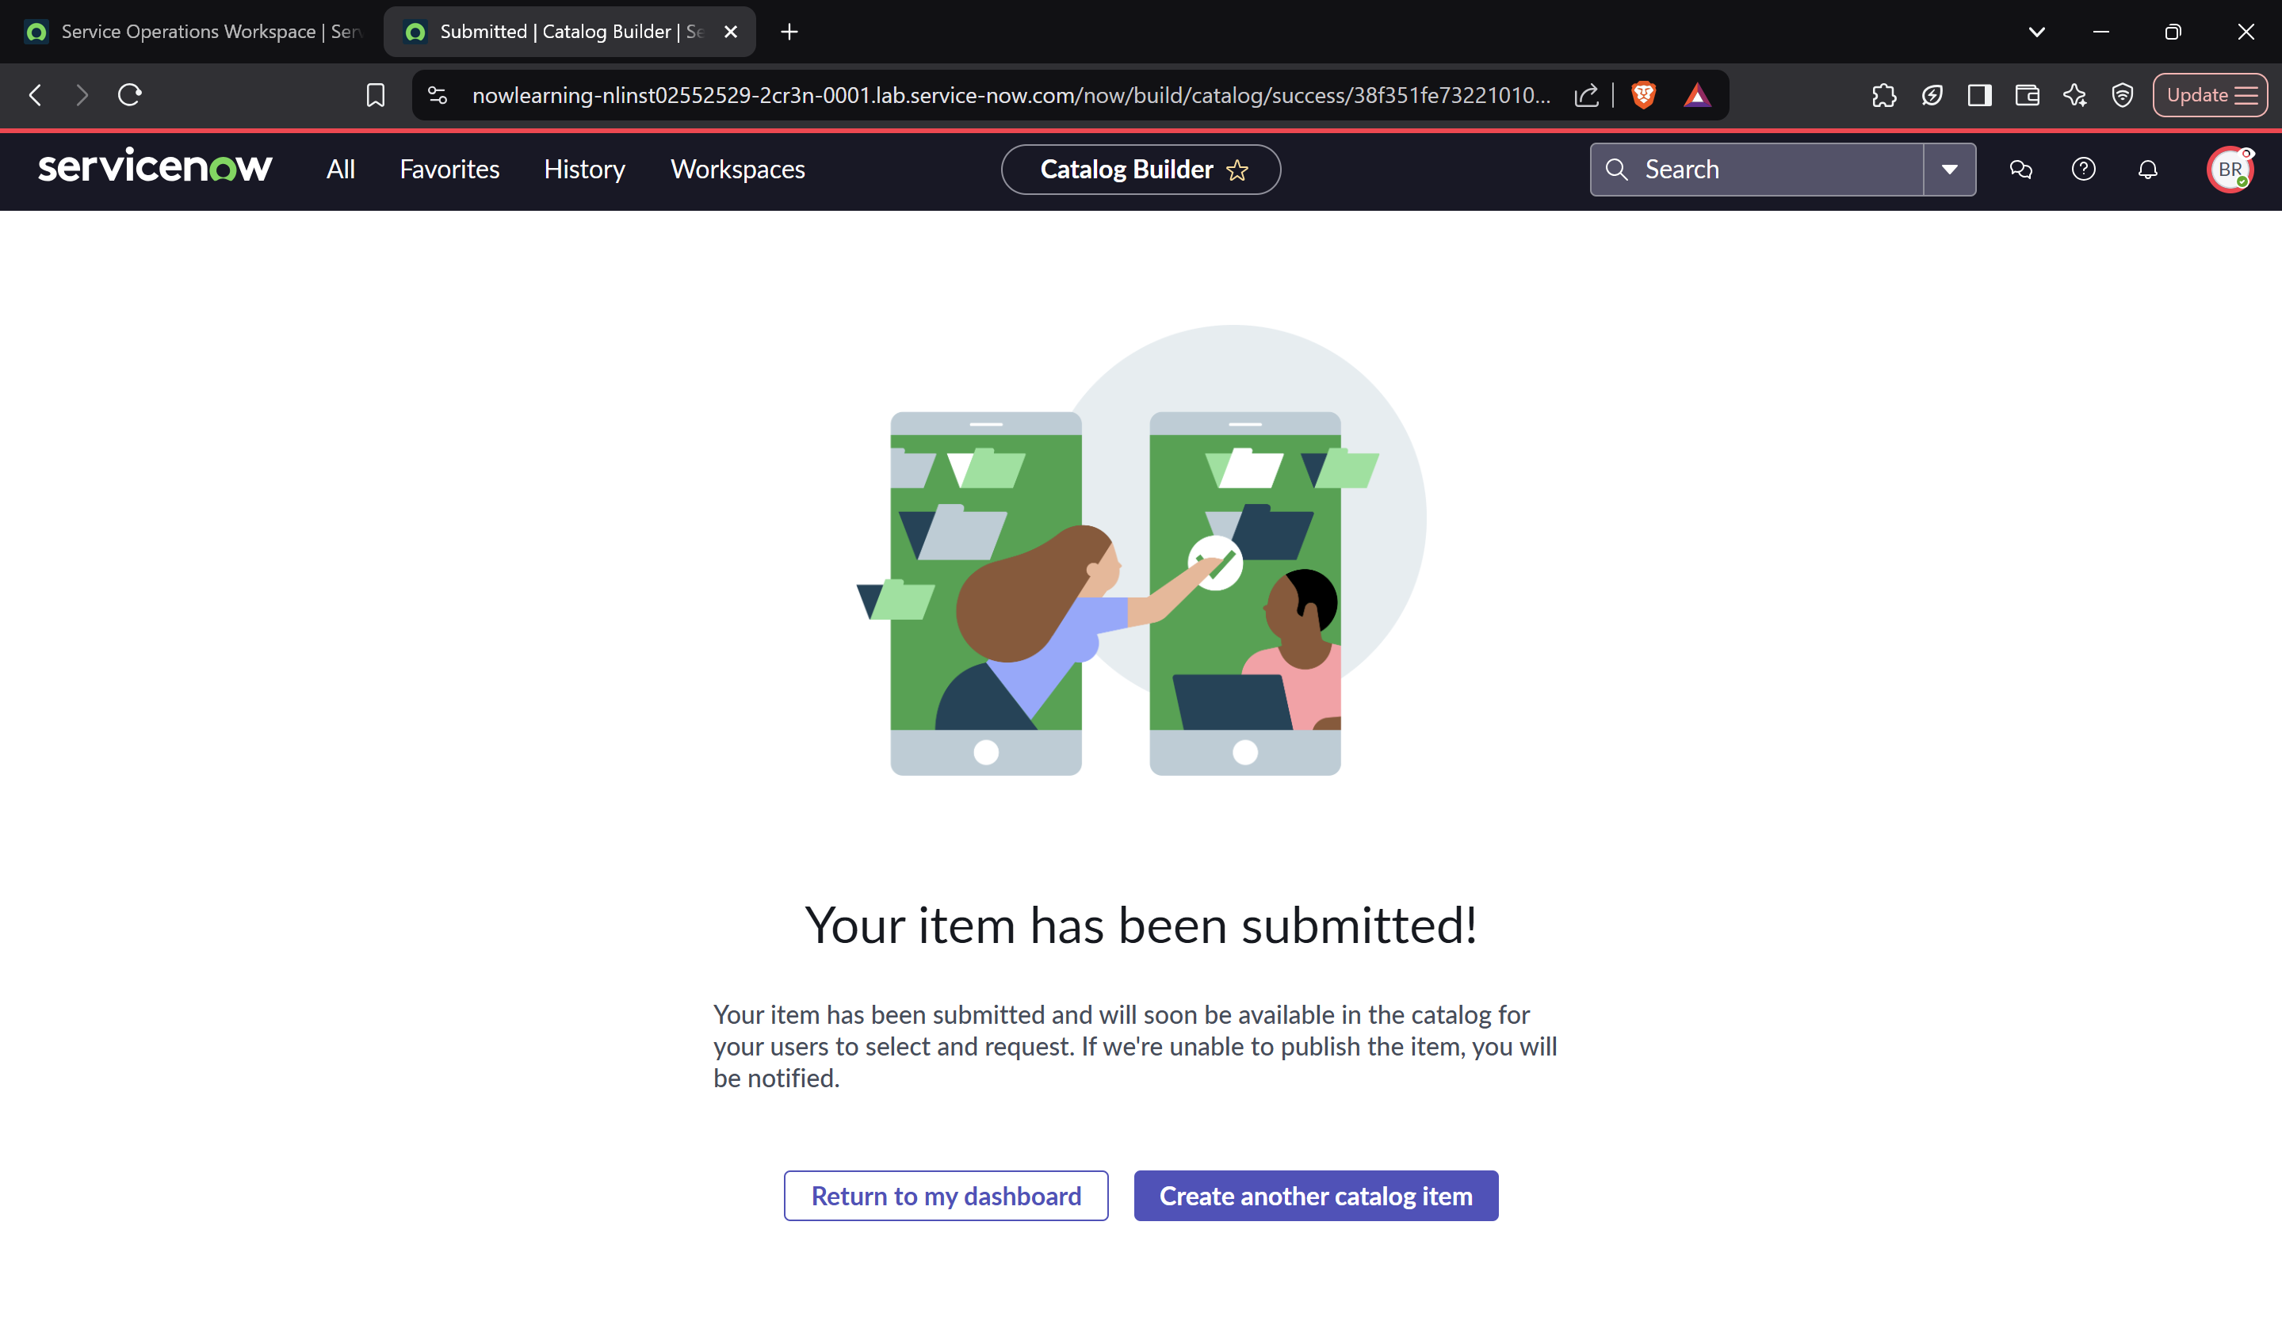

**Section 3: Add Pricing to the Infinity Catalog Item**

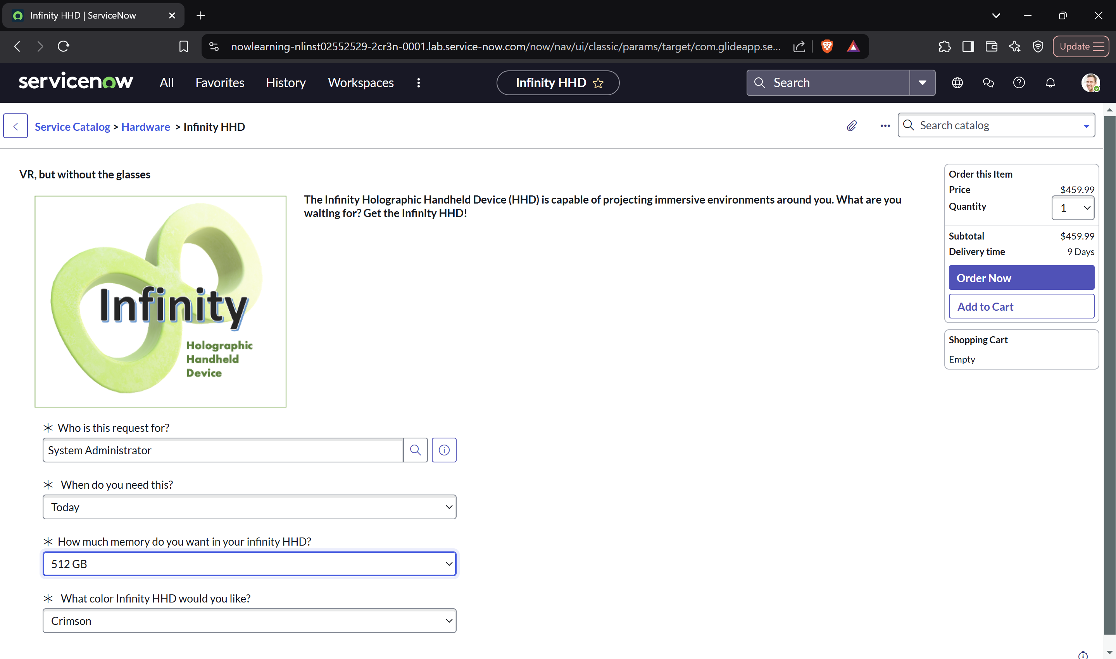

**Section 4: Verify the Service Catalog Item Creation**

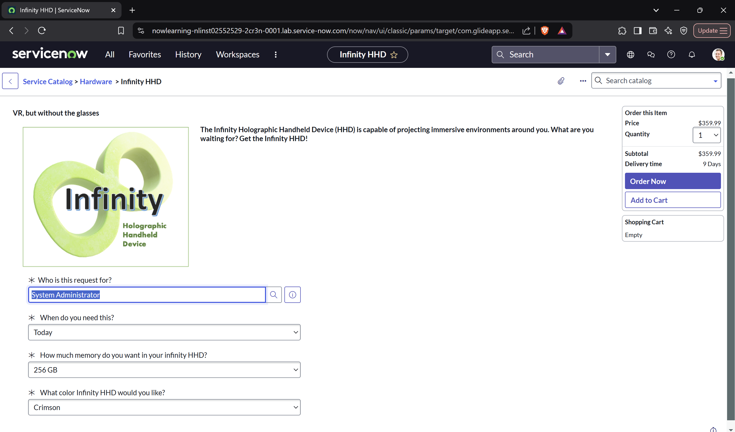

**Lab 5.3: Create a Flow Designer Flow**

**Section 1:**

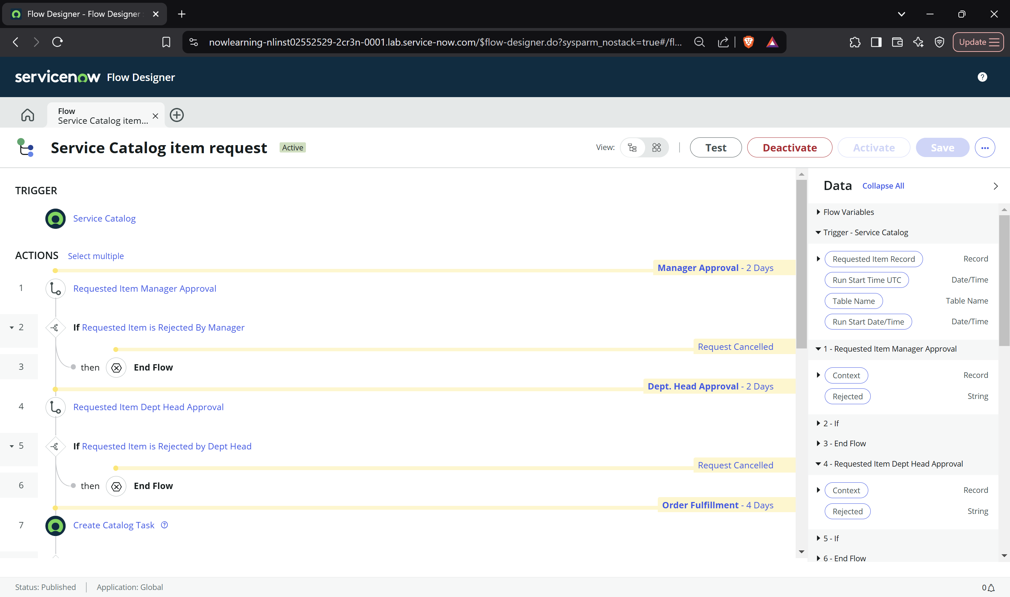

**Section 2:**

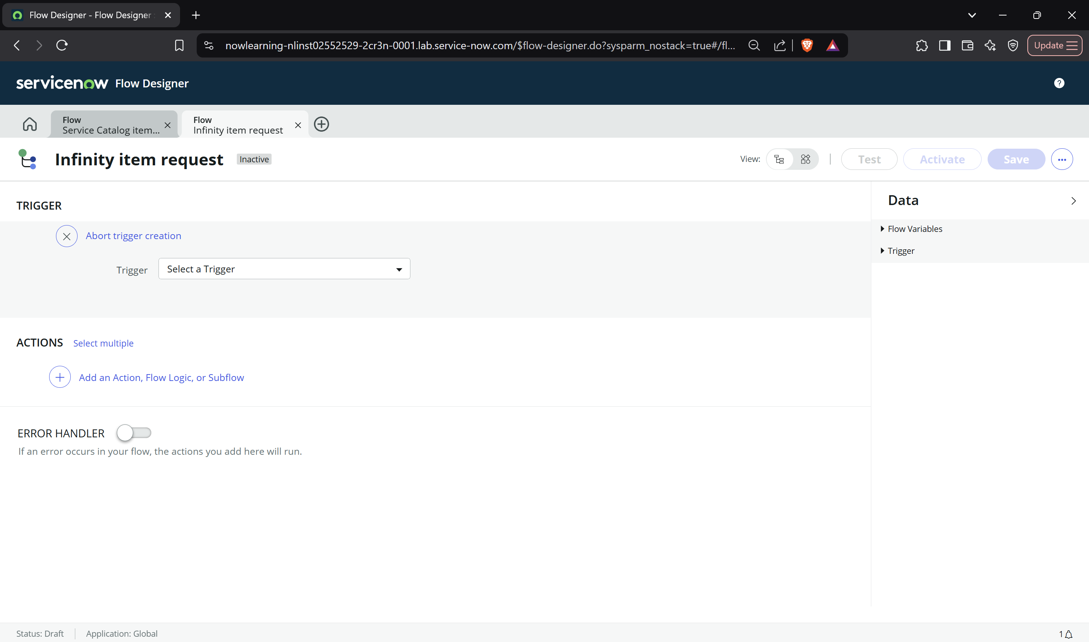

**Section 3:**

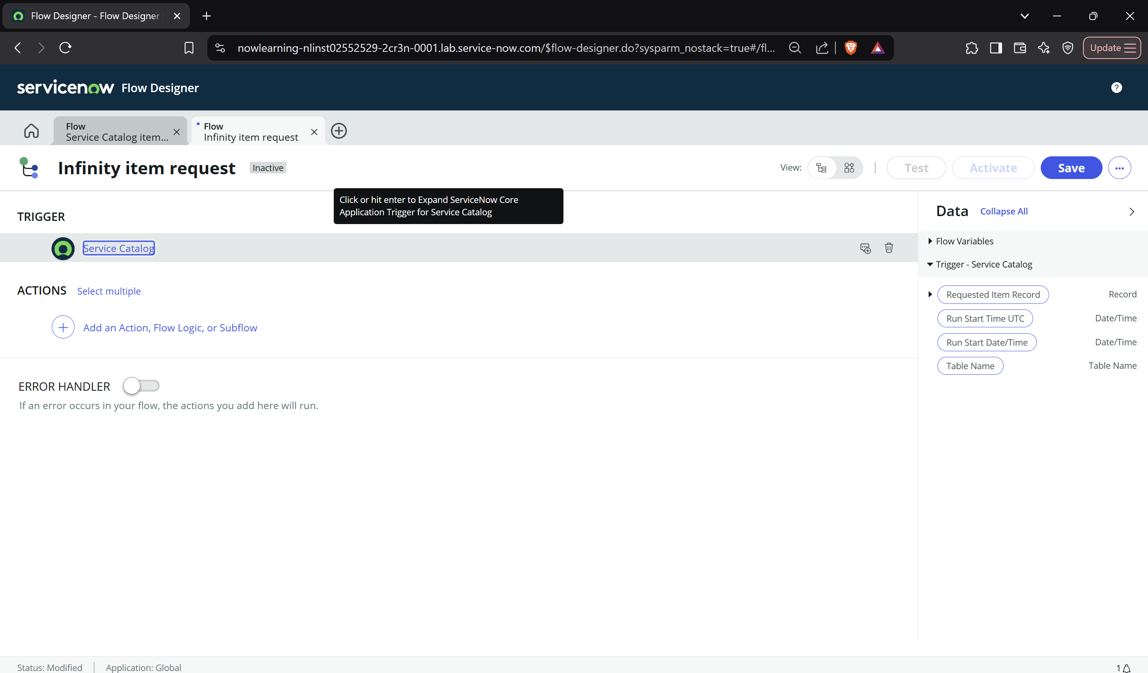

**Section 4:**

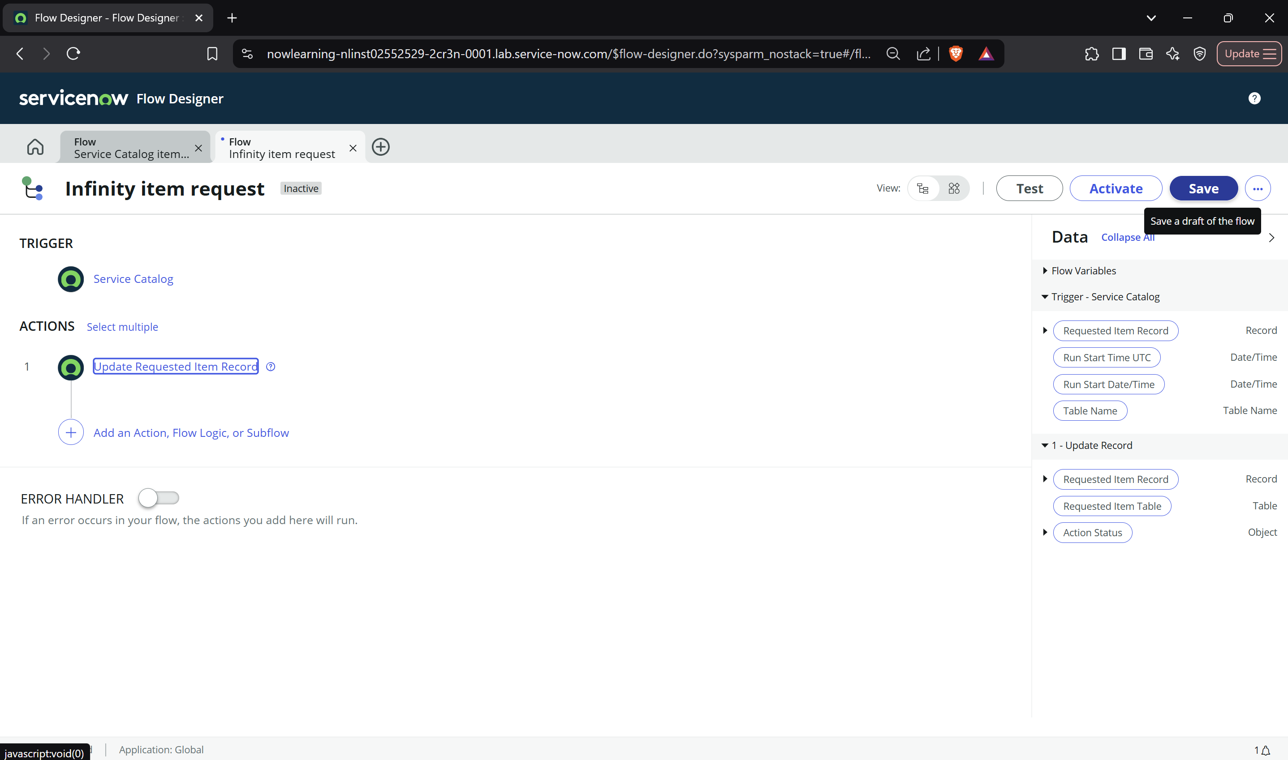

**Section 5 :**

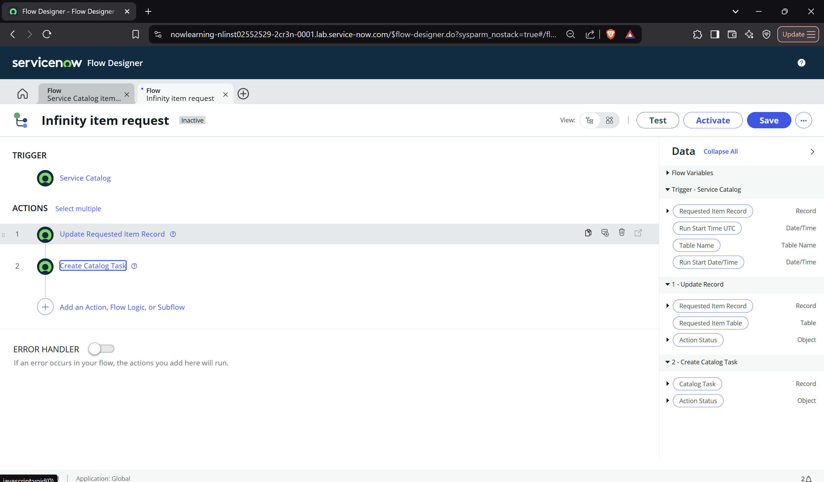

**Section 6:**

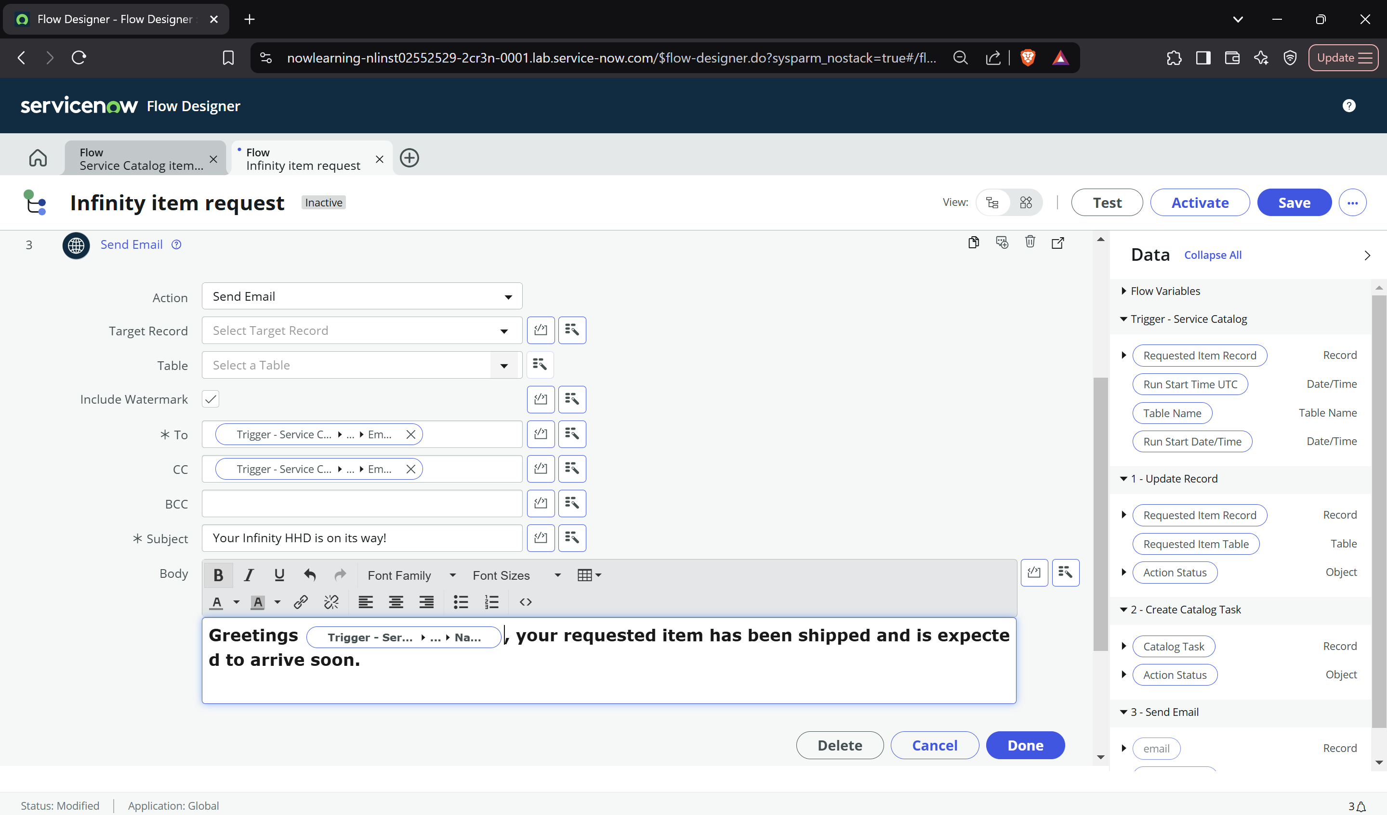

**Section 7:**



**Section 8:**

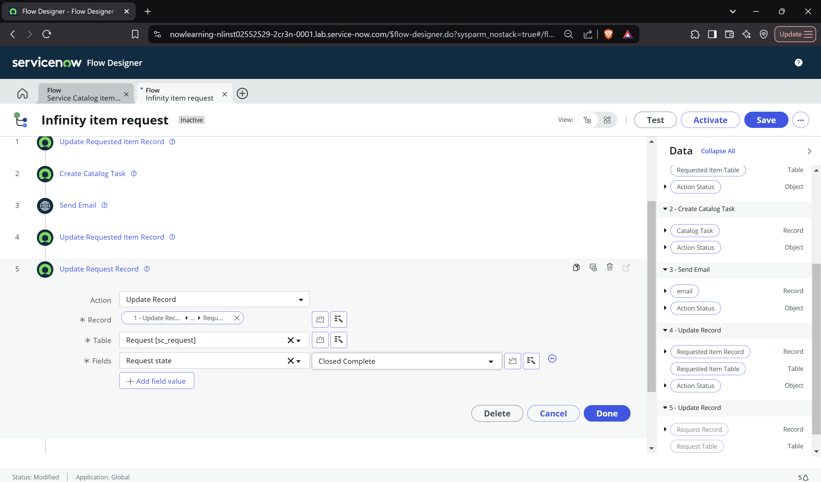

**Section 9 :**

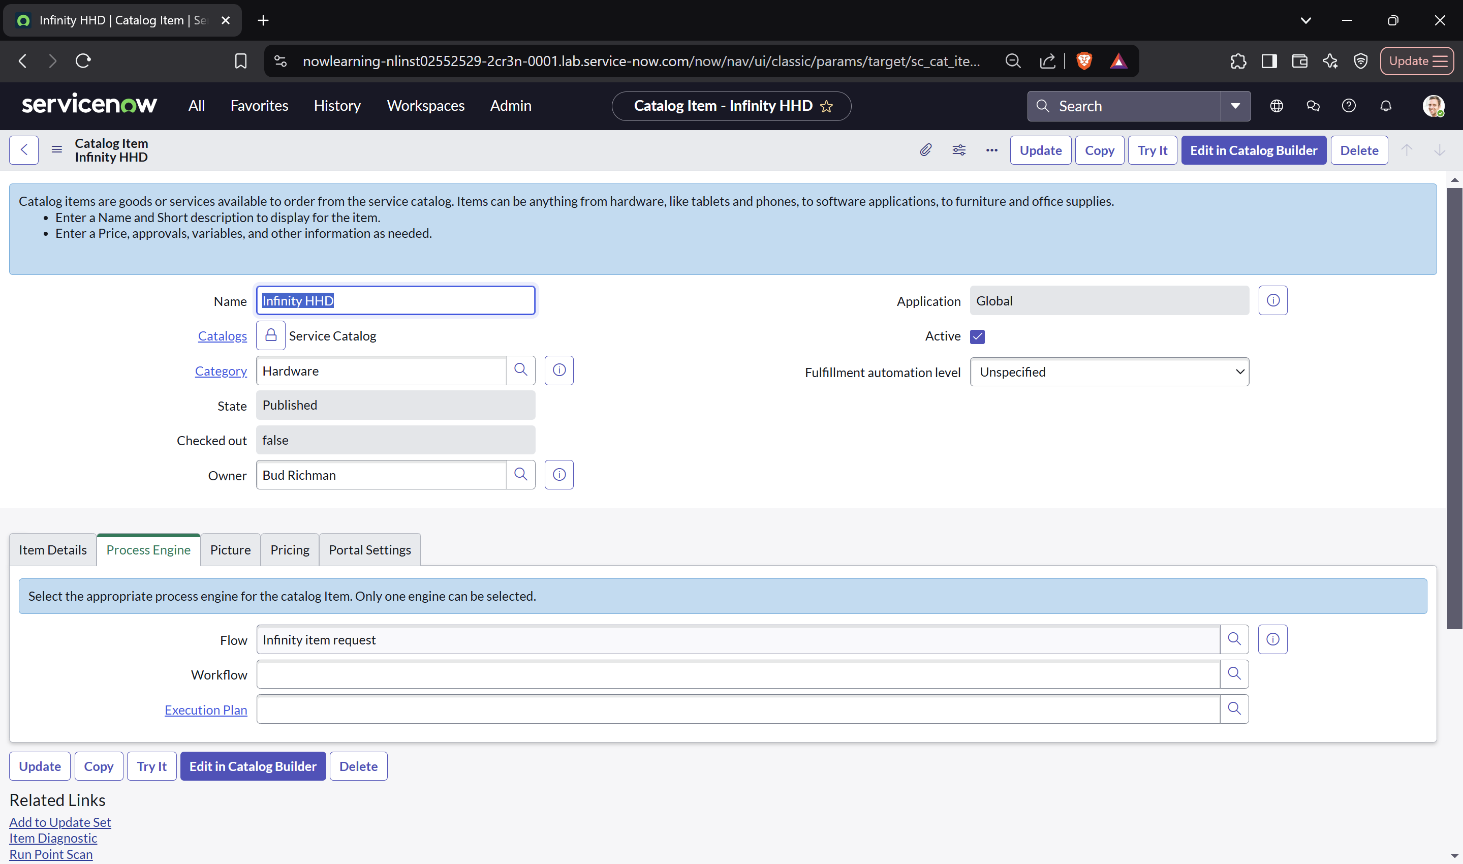

**Lab 6.1: Create Dashboards and Reports**

**Section 1:   
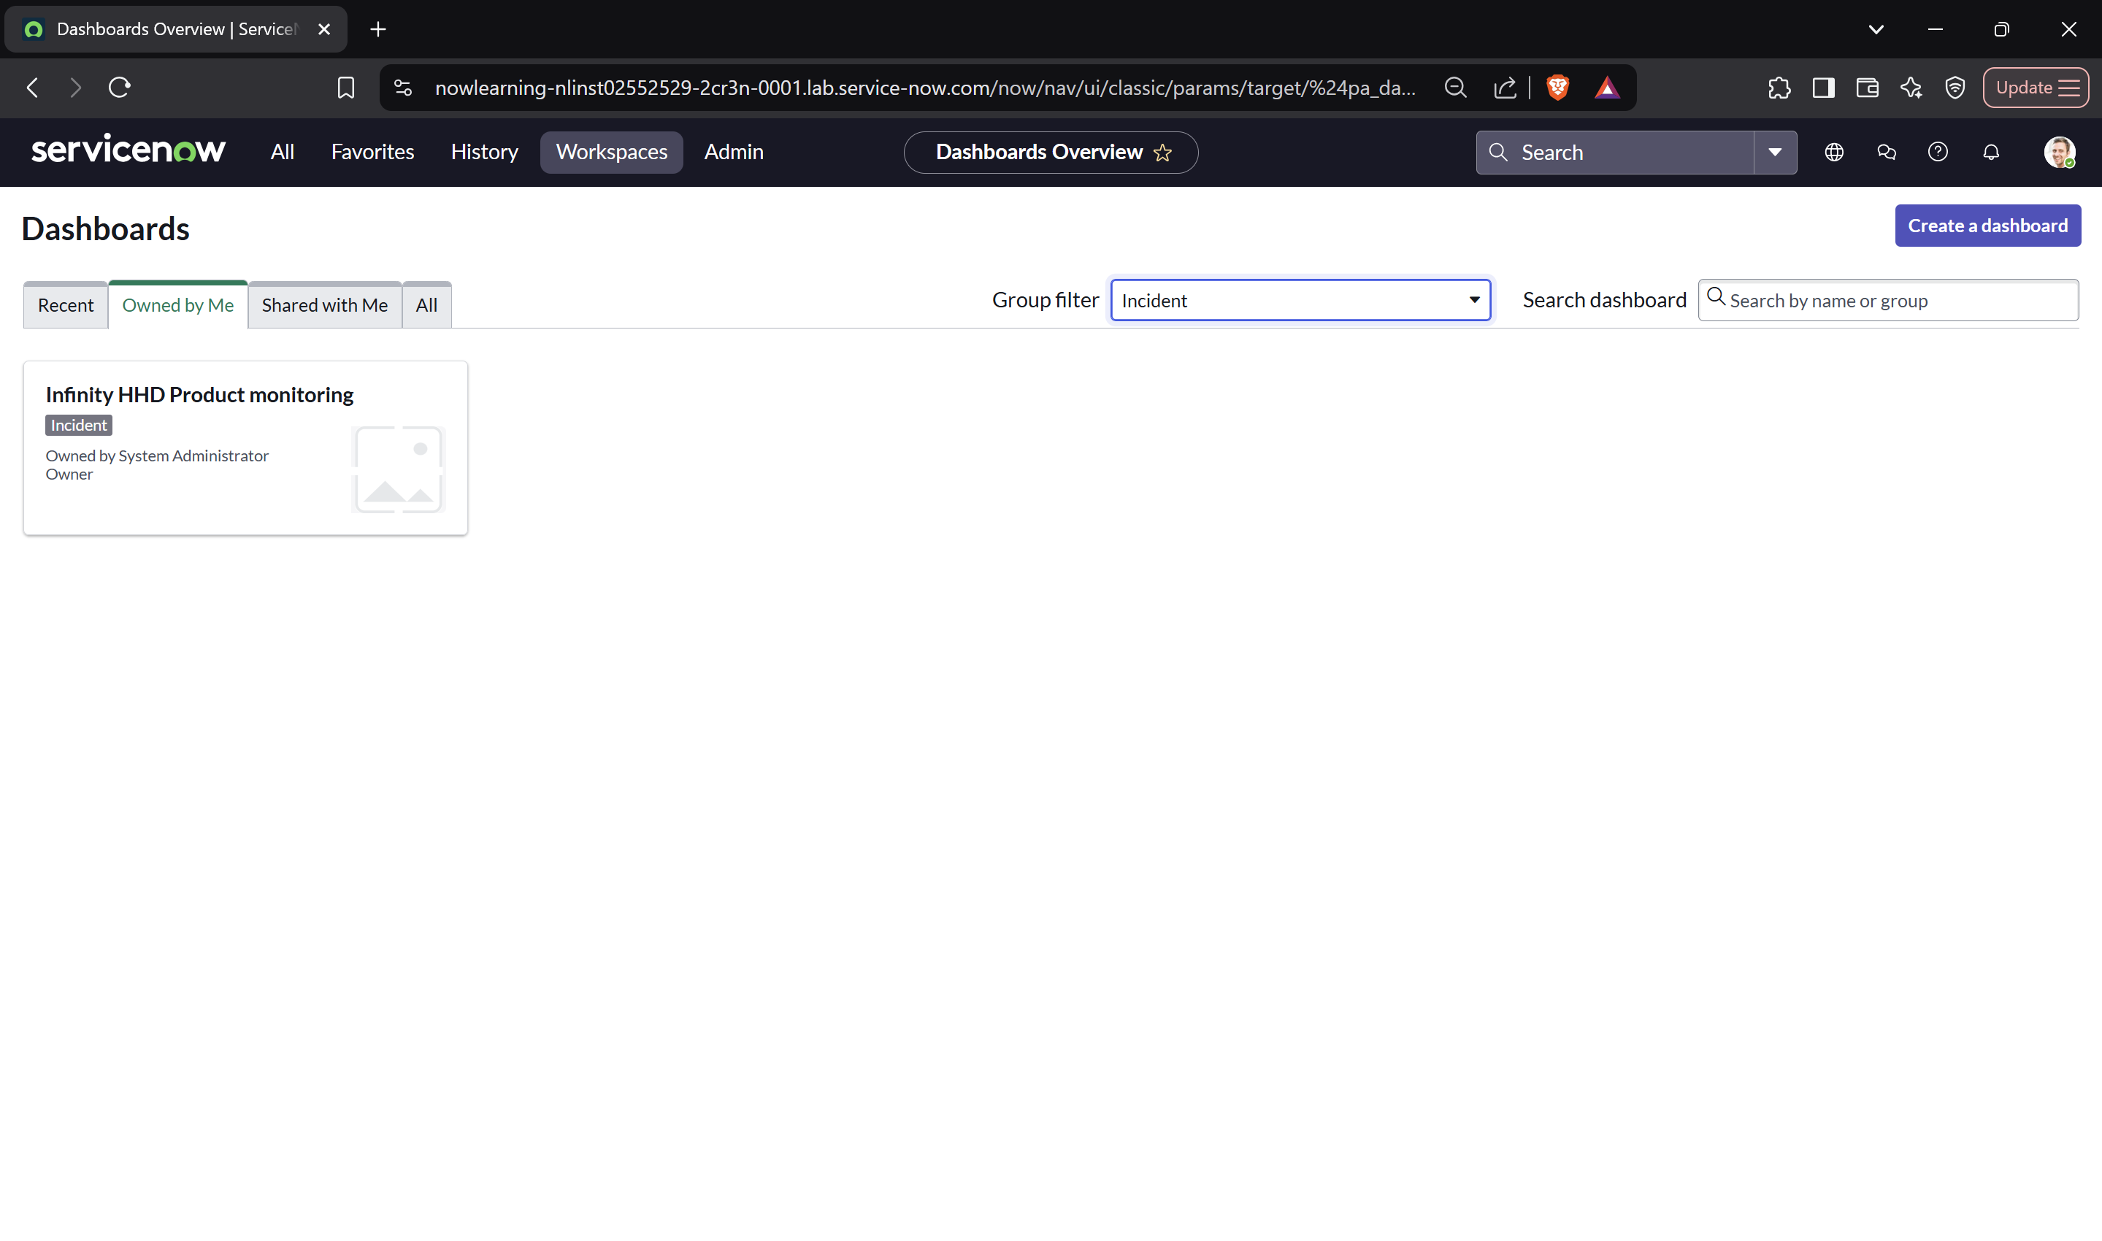**

**Section 2 :**



**Section 3 :**

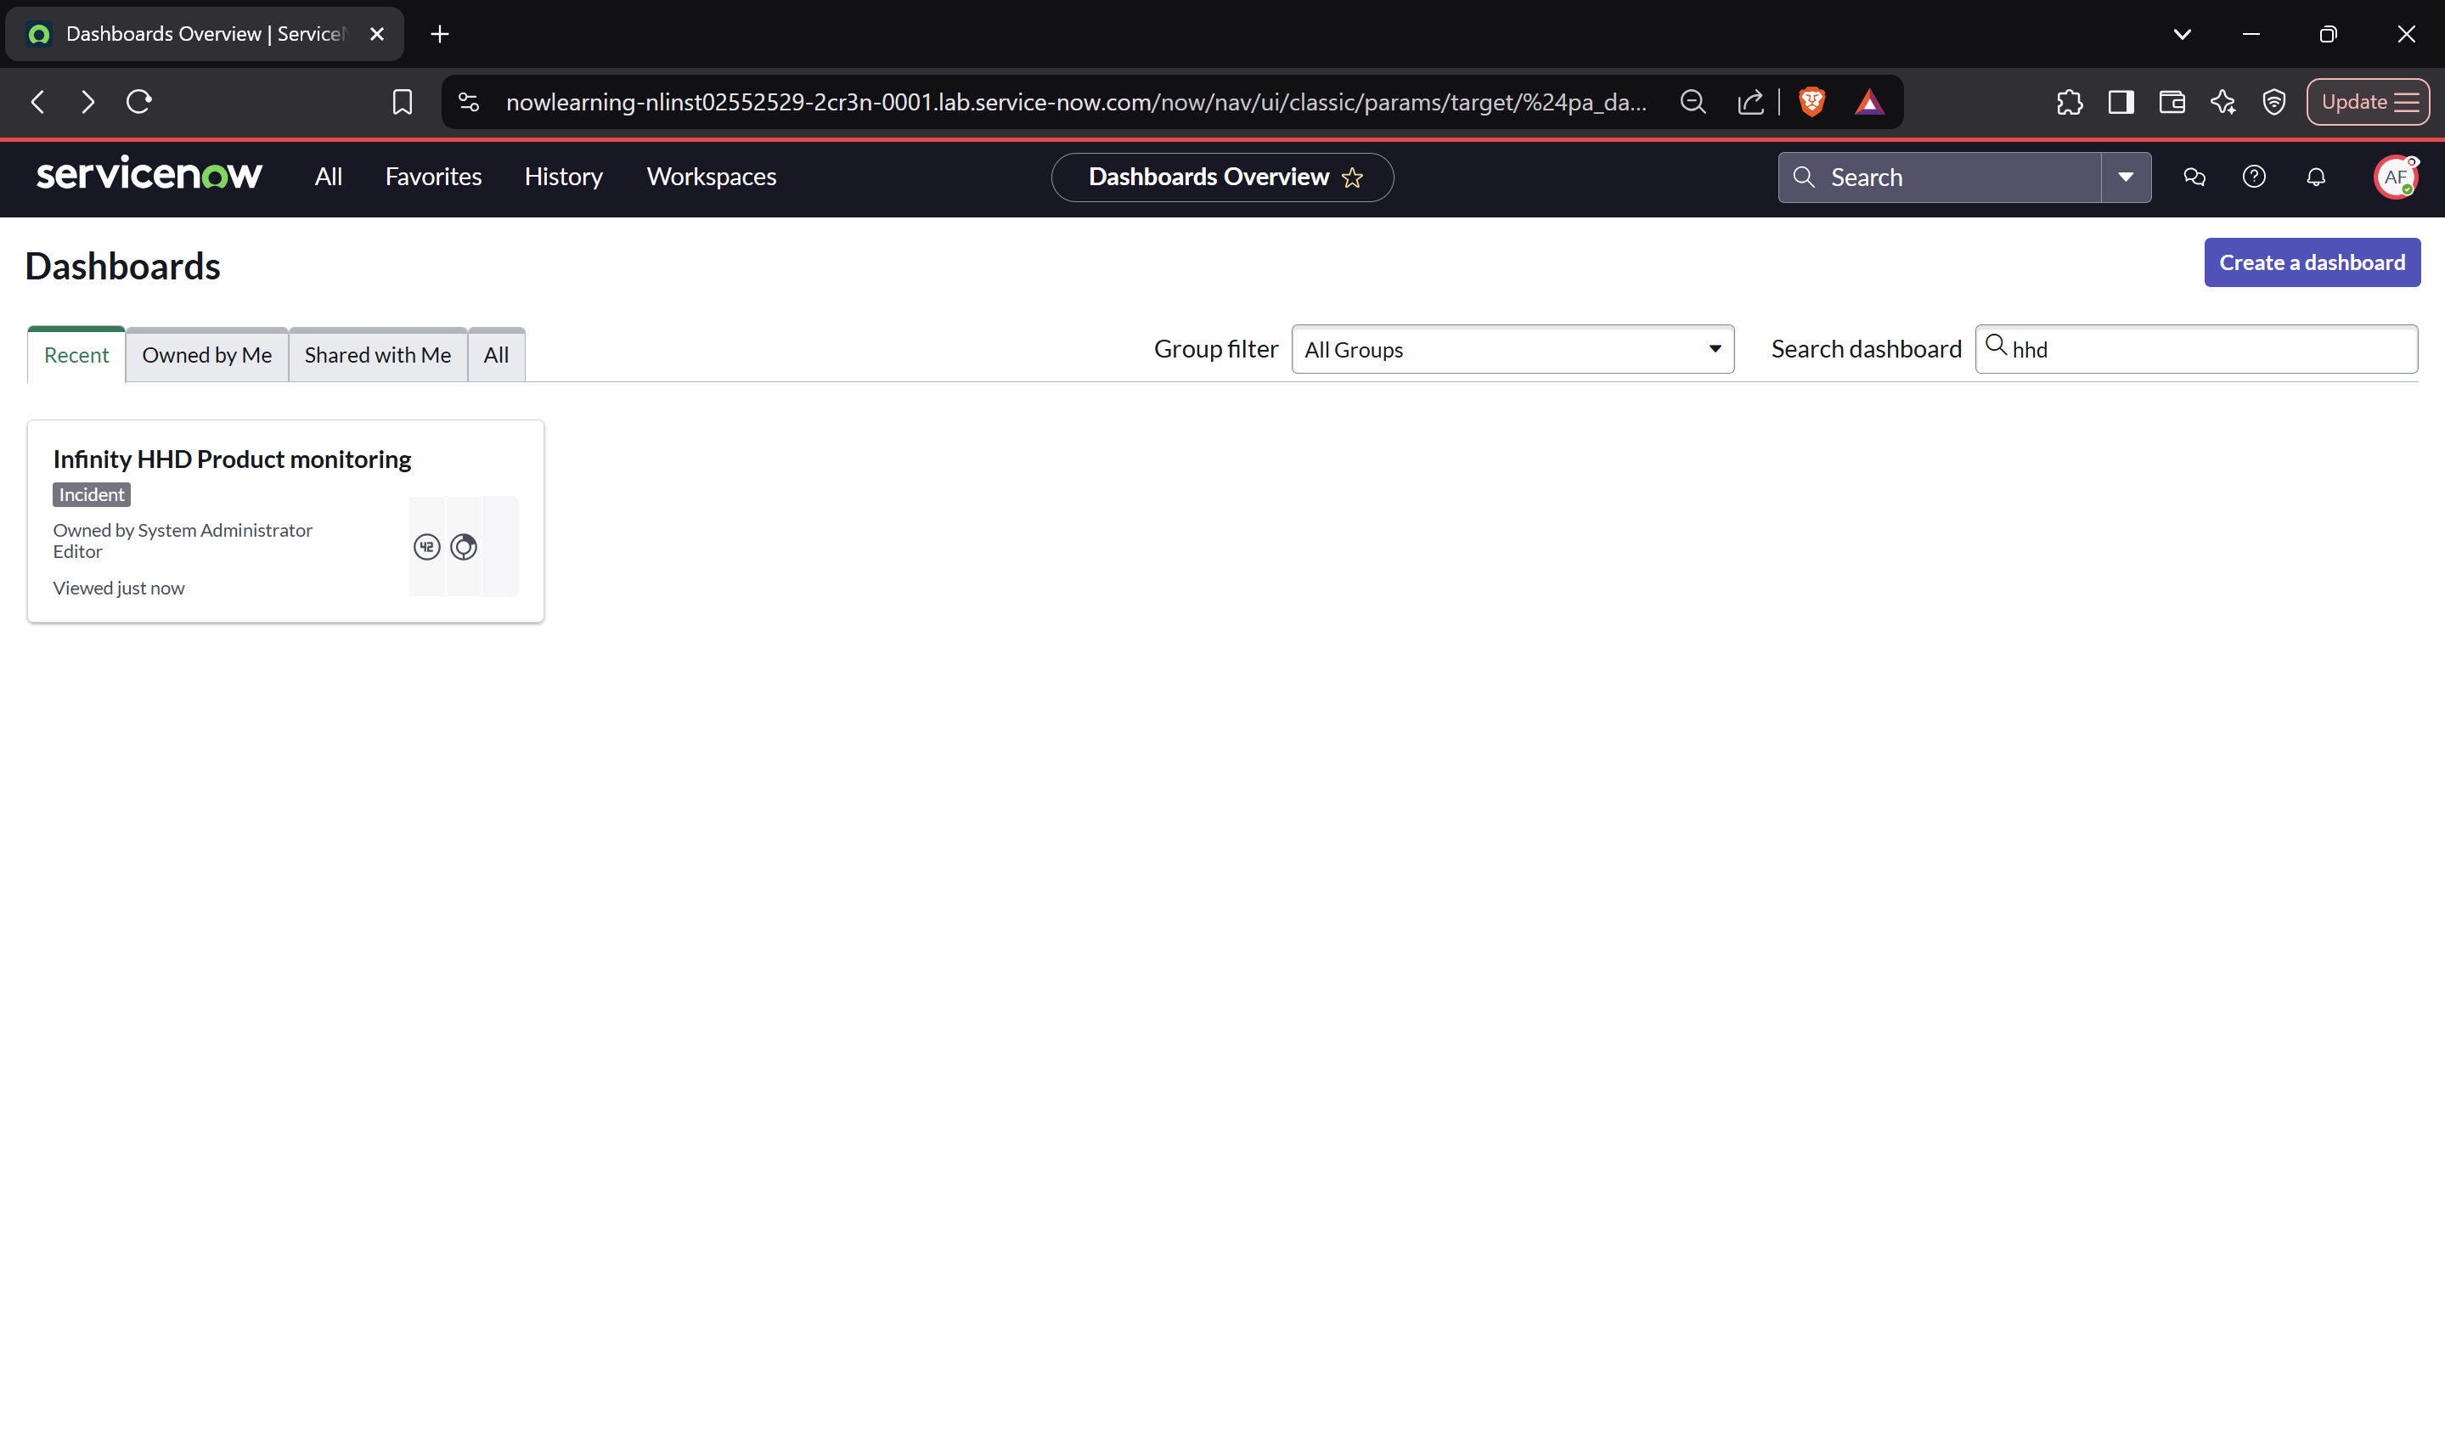

**Lab 6.2: Configure Notifications**

**Section 1:**

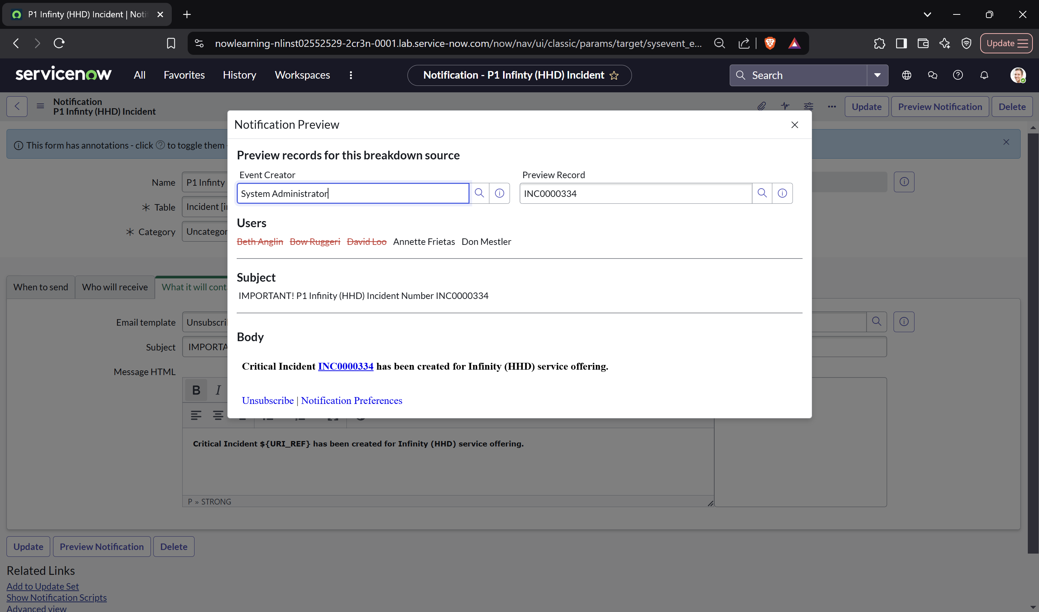

**Section 2:**

